

Graduate Certificate in

Intelligent Reasoning Systems

Project Report

IG4U--Intelligent Instagram Profile Analysis System

Group Members

Zhou Zhibiao (A0269368J)

Sureshkumar Sujatha (A0269371W)

Tan Jun Ming (A0269372U)

Lim Zhi Jing (A0269638J)

Table of Contents

1 Executive Summary 1

2 Business Case 3

2.1 Market Research 5

2.1.1 Market Competition analysis 5

2.1.2 Target Customers 6

2.1.3 Revenue Model 6

2.1.4 Market analysis 7

2.2 Project Objective & Impact 7

3 Data Preparation 9

3.1 Data Source 9

3.2 Data Acquisition, Cleansing & Feature Engineering 9

3.2.1 Development Phase 10

3.2.2 Production Phase 13

3.3 Database Structure 14

4 System Design 15

4.1 Architecture Overview 15

4.2 Knowledge Engineering 16

4.2.1 Model A: Rule-based Model 17

4.2.2 Model B: Clustering 21

4.2.3 Model C: Prediction by RF 22

4.3 User Interface 25

5 Application Architecture 38

6 System / Solution 39

6.1 System Implementation 39

6.2 System Performance & Validation 39

7 Real World Implementation 41

7.1 Introduction of sponsor 41

7.2 Insights to Khushboo Sewak profile 42

7.3 IG4U Recommendation 42

7.4 IG4U recommendation performance 44

7.5 Khushboo on IG4U 44

8 Conclusion 46

8.1 Project Conclusion 46

8.2 Challenges & Suggestion for Future Improvement 46

9 References 48

10 Table of Figures 49

11 Table of tables 51

12 Appendix 52

12.1 Interview with a Marketing Professional 52

12.2 Survey Questions for population study 54

12.3 Market Competitors 55

12.4 Project Proposal 57

12.5 Mapped System Functionalities against knowledge, techniques, and skills of modular courses: MR, RS, CGS 65

12.6 Installation and User Guide 67

12.7 Individual project report 67

GitHub Link: [***https://github.com/sujatha-sureshkmr/IRS-PM-2023-01-28-IS03PT-IG4U***](https://github.com/sujatha-sureshkmr/IRS-PM-2023-01-28-IS03PT-IG4U)

*Source Code Link:*[***https://nusu-my.sharepoint.com/:f:/g/personal/e1112242_u_nus_edu/Et0EjC8BnsVLnW-2asmU43ABNiLQSkhdHt5KKUYm9PgqYQ***](https://nusu-my.sharepoint.com/:f:/g/personal/e1112242_u_nus_edu/Et0EjC8BnsVLnW-2asmU43ABNiLQSkhdHt5KKUYm9PgqYQ)

Promotion Video: https://youtu.be/45o6p-snwMc

System Video: https://youtu.be/gVqio2x1xQg

# Executive Summary

This group project is one of the key deliverables for the Graduate Certificate in Intelligent Reasoning Systems; and this report documents the extensive and meaning work the group has performed in developing an intelligent system **to assist individuals and businesses to make better use of social media platform – *Instagram***. Specifically, our developed system will allow users to better understand their own Instagram profile via detailed analysis and provided key recommendations for improved outreach and marketing.

With the increase usage of social media in recent years, there has also been an increase in the adoption of social media marketing. Instagram is one of the most popular social media platforms among Instagram influencers, brand ambassadors and other marketing professionals. Individuals who aspire to be influencers are posting creative contents on the platform to garner more popularity, while many businesses are posting marketing contents or promoting various products/places. This itself generates income to influencers and brand specialist. Various organisations lookout for Instagram influencers based on their followers and impressions to promote their product thus achieving maximum outreach of the products.

Based on our interview with a marketing executive and surveys with individuals and business owners, we have identified that there is a **lack of easily available tool to assist influencers**, **as well as Small and Medium-sized Enterprises (SMEs)** to improve their presence and outreach on social media platform like Instagram. This stem from the fact that multinational corporations (MNC) and large local enterprises (LLEs) often have internal marketing team or external media agency responsible for the management of the corporate Instagram account; while SMEs do not have the financial capability and expertise to do so. As such, through the development of an Instagram analysis and recommendation software, our group hopes to provide influencers and SMEs with a user-friendly application to improve their presence and marketing on Instagram. Overall, we hope that our software will improve their businesses and profits.

Our proposed software, titled **IG4U**, is built on a database which consists of 200k of Instagram posts. Using a combination of **Natural Language Processing**, **rule-based** and **regression modelling**, our software consists of a four stages process involving **data pre-processing**, **topic modelling**, **knowledge base inquiry** and **recommendation plan**. IG4U has webpage interface for the ease of user interaction, as well as a python scripted backend in which the team developed the model and analysis. Furthermore, IG4U employs the hosting database software Elephant DB to manage the user login and signup. Our group makes use of the flask framework to perform the integration between the backend and the webpage. Each session generates user profile and posts capped at latest 5000 posts and saved in csv for future processing and UI utilization.

Within the short time span of approximately 15 weeks, the group is **launching the beta version of IG4U**. The software has been assessed to have met the requirements which include performing profile analysis of the user and perform recommendation to the individual or SMEs. Furthermore, we got positive feedback from professional social media agent for the IG4U beta version, as well as other individuals’ positive feedback during test stage. At the same time, the group recognise some of the limitations for the current version of IG4U mainly on retrieving humongous posts from Instagram. We hope to gather the feedback for this beta version of IG4U and perform further development to the software via the introduction of features. Overall, we are proud of the work in this project, at the same time recognizing the boundless potential to further improve our product.

# Business Case

The significant growth in the usage and adoption of social media in the world have resulted in companies adopting brand marketing via social media platforms. This trend is here to stay as the popularity of the social media platforms is still on the rise as reported in the global social media statistics research summary for 2023.

Various organisations lookout for Instagram influencers based on their followers and impressions to promote their product thus achieving maximum reach of the products. This itself generates income to influencers and brand specialist. Business Of Apps quotes following key statistics of Instagram.

* **Instagram key statistics**
* Instagram generated an estimated $51.4 billion revenue in 2022, accounting for almost 45% of Facebook’s total revenue
* Over two billion people use Instagram once a month, making it the fourth most popular social app worldwide
* Instagram’s biggest market in terms of users is India, with over 300 million active users
* Over 70% of Instagram users are under 35 years old

In recent years, among the various social media platforms, Instagram has grown exponentially and has become one of the most popular social media platforms among users. As of January 2023, Instagram has over 2 billion active users and is the 4th most used social media platform in the world as shown in *Figure 1* (Dave, 2023). Furthermore, Instagram’s unique function of allowing users to follow brand and find information about products make it ideal for businesses to connect with their target audience and promote their brands.

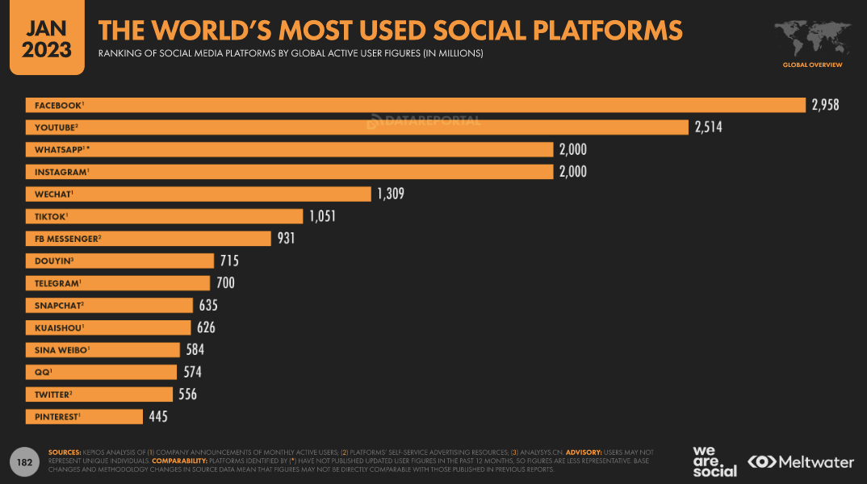

*Figure 1. The world's most used social platforms*

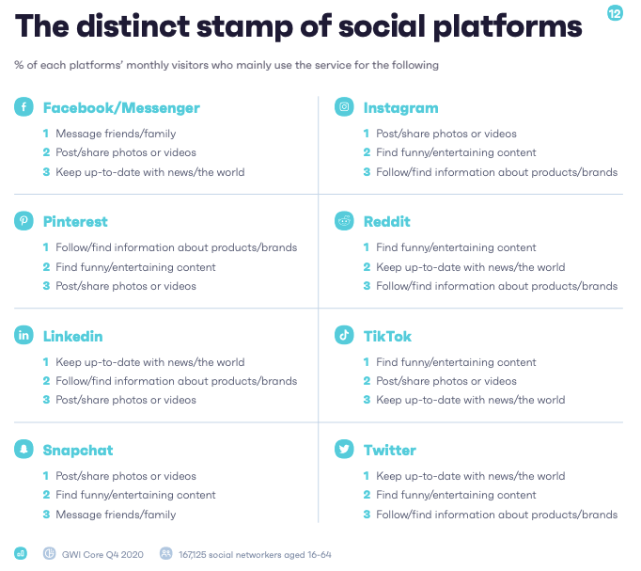

*Figure 2. Key features of the various social media platforms*

Indeed, many of our peers and ourselves are avid users of Instagram. As such, this triggers the idea of developing a useful application to assist Instagram users to better manage their accounts for personal and business branding.

Firstly, most of us have a personal Instagram account and have been on the platform for years. Top most common issues faced by business users were the struggle with content creation and attractive Hashtags. For our survey, 100% of business owners who have responded mentioned the following three as their main challenges – hashtag creation, captions drafting and trends analysis. As a result, our group focuses on these aspects to tackle these challenges.

Secondly, to better understand how the businesses use Instagram as a marketing platform, our group conducted an interview with a marketing professional, Seah Jun Hui, who has more than 5 years of experience in the marketing industry in various organisations such as M1 Limited, CIMB and HSBC. The email reply for the interview is attached in the appendix of this report (Section 12.1). From the interview, it has been noted that multinational corporations (MNCs) and large local enterprises (LLEs) often have internal marketing team or external media agency responsible for the management of the corporate Instagram account. However, small medium enterprises (SMEs) usually do not have the manpower and budget to do. As such, the Instagram account is often managed by one of the staff on an ad-hoc basis who might not be specialised in marketing. Therefore, our group believes that an application which targets SMEs would be greatly beneficial.

Lastly, one of our team members has contacts who are business owners in the small and medium enterprise shared some of their struggled with their brand awareness using social media platform such as Instagram. This spurred us to want to use our skills and knowledge gained in this course to help them with their business case.

With the above considerations, our group aims to create a tool which will provide the following features for both personal and SMEs users:

1. Basic Instagram account’s analysis
2. Post recommender
3. Instagram Posts’ description sentimental analysis

## Market Research

The world is not new to automations or other robots in assisting the human lives for a better front, and this is also true for social media platform like Instagram. Since the launch of Instagram social media platform almost 13 years ago, there have been various tools and robot automations surfaced in the market which aims to help content creators and account owners to gain popularity or an edge against their competitors.

### Market Competition analysis

There are several existing tools which are available in the market. These Instagram growth and management tools primarily focuses on scheduling and managing posts, rather than recommending a personalised post or comments that helps to grow the audience base. They also do not analyse the quality of the account comment which will appeal to the audience base of their account.

Moreover, some of these bots or automation services (Taslaud, 2023) are working against the Instagram’s terms of use, where it can result in account suspension or even closure. (Meta, 2023) Examples of such misuse of terms includes automating the tasks or content creation, following of bots or fake accounts to boost follower base. Our product focus on assisting the business owners to understand how their account post or comment stands against their competitors, or to recommend post or comment which are personalised, AI-driven to growing their audience base which is in line with Instagram’s terms of use.

Some of the competitors found during our research includes Iconosquare and AI Grow, which them both gained quite impressive reviews from the users. They provided features such as competitor analysis and hashtag recommendations as some of the top feedback from users which are their primary reason for choosing them. As with every good tool or product, there bound to have negative feedback for the usage. In one of the review posts, it is noted that competitor analysis is taking more than a day for it to be reflected. This is where our team strive to use our algorithm to gain an advantageous edge.

### Target Customers

Our target customers are social media influencers, brand specialist and SME business owners or their business’s marketing team who wants to grow their account and increase engagement. This comprises of small and medium businesses, enterprises, influencers, and individuals who uses Instagram for their personal branding, product, or services. Our products appeal to those who are willing to commit to growing their accounts organically and are willing to invest their time and effort to achieve their goals.

### Revenue Model

We planned to adopt two price plan model, one being the free account, and the other a subscription-based revenue model, with monthly or yearly fees. The free account will comprise of basic account analysis, where the paid account will offer a range of functionality and support.

Free model provides analysis of an individual posts and comes up on the overall analysis of their page, performance, sentiment of the profile and other various facts.

Subscription account comes up with the following functions on top of the overall analysis:

1. Topics that provides maximum reach
2. Skills
3. Understanding their profile – Prediction of likes that is targeted to be achieved and the actual likes. Various topics and its performance with respect to the Instagram profile.
4. Recommendation:
   1. Consistency
   2. Hashtags
   3. Collaboration with other accounts
   4. Instagram Ads

### Market analysis

To determine the potential demand for an Instagram recommender and growth software, we had conducted surveys and interviews with a sample of 140 people consists of SMEs business owners, influencers, and individuals who use Instagram for their personal branding, product, or services. The survey and interview questions focused on their Instagram usage, goals for their accounts, and their interest in using a personalised account recommender and growth software features.

#### Results

The survey and interview results revealed that most Instagram users are actively seeking ways to grow their accounts and increase engagement. This is especially so for the small and medium enterprise business owners where they are facing difficulties in getting ideas for content and hashtag creation. With a 100% agreement from our survey of business owners from small and medium enterprise, this spurs us to work hard on the recommender tool for them.

## Project Objective & Impact

Our project objective is to offer a better alternative to the social media influencers and small and medium enterprise business owners who are interested in gaining better brand awareness and content quality of their business posts in the Instagram social media platform of their business account. We aim to provide features that will let them gain a better understanding on where their account strength and weakness are.

In our product IG4U, user would be able to register for either a free or paid account, and they will be able to gain knowledge and account analysis of their business’s Instagram account or their competitors through simple Instagram account query in the local website of our platform.

To gain a good coverage of the market, we went through an extensive processing of over 200k valid Instagram posts data, built our data models and algorithm from it. This allows our users to have a competitive edge by referring through a large data base for analysis.

Our product is also able to get live feedback update of the interested business account changes or latest post upon querying. This allows user to gain a better understanding on their post’ strength and weaknesses, and their estimated forecast of content performance.

# Data Preparation

This section discusses the acquisition and processing of the data used in this project. Data is the basic building block of an Artificial Intelligence (AI) system which is vital for model development and analysis. In the early stages of this project, a significant amount of time was spent on understanding and processing of the available Instagram data. As a result, we obtained a good performance hybrid system with various models trained by this dataset.

## Data Source

The dataset used in this project was taken from Kaggle which is one the world’s largest public data source providers. The authenticity of the data has been verified by performing random sampling and cross checking of the user’s profile on Instagram platform.

## Data Acquisition, Cleansing & Feature Engineering

The Instagram dataset consists of 3 different comma-separated values (CSV) file which provide the following 3 different sets of information:

1. Post: Details of each post on Instagram
2. Profile: User profile information
3. Location: Instagram database used for location tagging in the post

The entire dataset consists of over 1 billion Instagram posts. For this project, the group extracted 3 million posts which were deemed as an ideal size for our application development (i.e. clustering and prediction model training). The data processing steps are as discussed below.

This dataset is used during the development phase of our application to train various prediction and recommendation models. Furthermore, during the user session, the application will connect to Instagram API to download the profile and post information. The dataset will also be used for the analysis of the downloaded profile.

### Development Phase

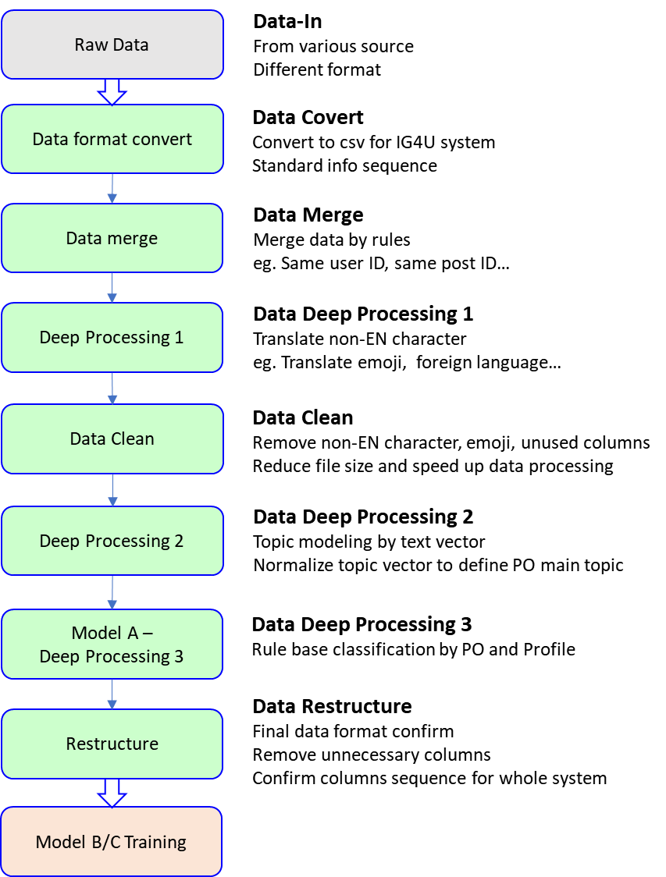

*Figure 3. Process flow for data preparation during development phase*

To prepare the dataset for model training, a series of data processing steps were performed. The process flow is as illustrated in *Figure 3* and consists of the following key steps.

1. Merging of data

The data in the 3 CSV files (post, profile, location) are linked to one another via common columns (see *Figure 4*). Specifically, in the post CSV file, the ‘profile_id’ and ‘location_id’ columns allow each post to be matched with a profile and a tagged location respectively. The merged data provide information on the post content, the profile who has created the post as well as the location tagged in the post. This information will be used for model development.

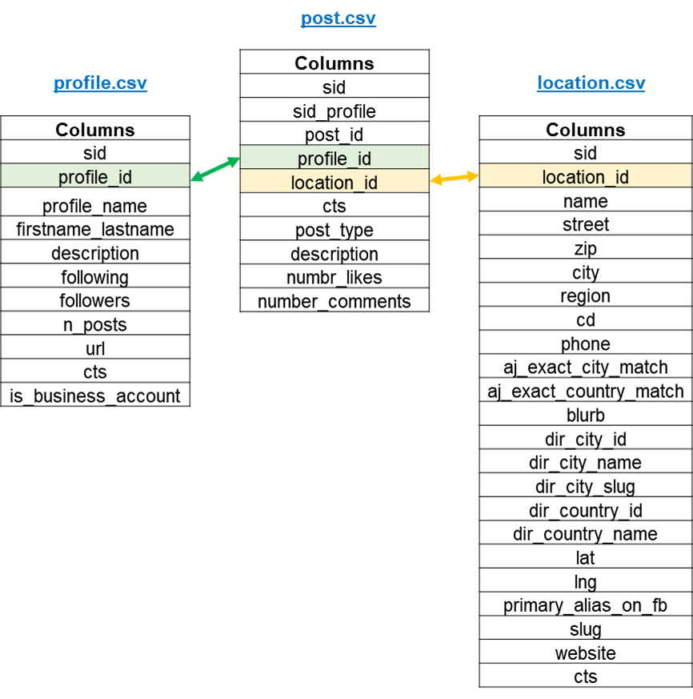

*Figure 4. Merging of data in the 3 CSV files with a common column*

1. Cleaning of data

Data cleaning was performed to remove redundant information in the dataset which is not required for the development of our application. This includes columns which have a high percentage of empty values (>45%) and columns which do not provide useful information for analysis (i.e. index, sequence ID, etc). The removed columns are highlighted in *Figure 5* below.

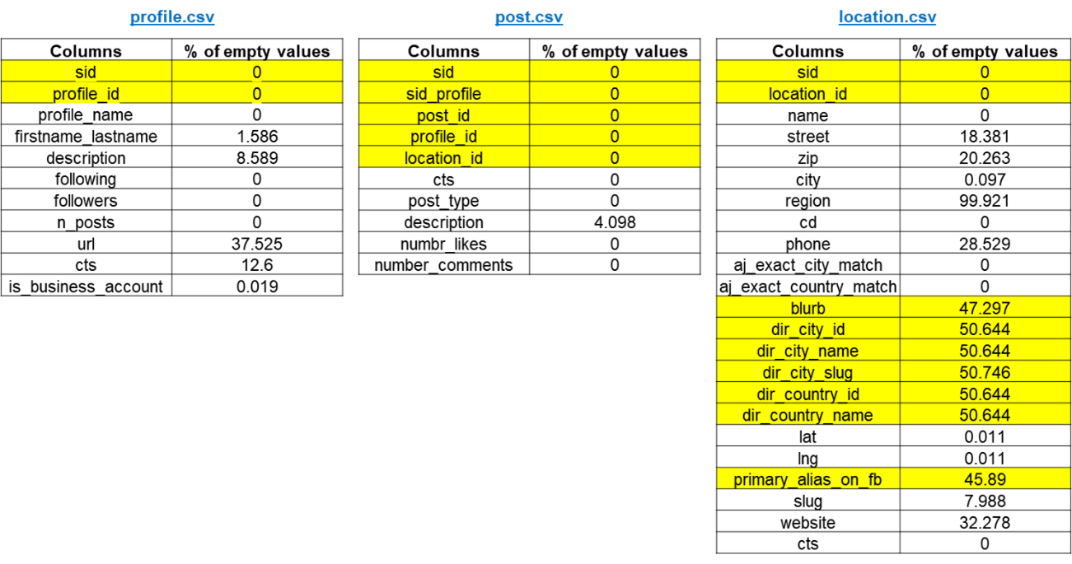

*Figure 5. Cleaning of dataset*

1. Deep processing of data

A series of data processing was performed on the dataset to prepare it for analysis and model training.

**Feature engineering 1**

The two description columns in the dataset, PO_description[1] and PRO_description[2], are sentences which were crafted and written by the users. They include useful information such as hashtags, tagged accounts and emoji. To retrieve this information for analysis, the following were performed:

1. Retrieval of hashtags and tagged accounts into individual columns
2. Identification of emojis and translating it into text
3. Removal of new line and carriage return characters
4. Identification of language and translate to English for foreign language

**Feature engineering 2**

Topic modelling was performed on each post entry to identify the main topic the post was addressing. The input to the topic modelling is the PO_description column which include hashtag, emojis, text description. 10 different topics have been identified from the dataset as shown in Table 1.

Table 1. Identification of topic from topic modelling

|  |  |
| --- | --- |
| **Topic Number** | **Topic Identification** |
| PO_Topic0 | PO_Food |
| PO_Topic1 | PO_Work_Event |
| PO_Topic2 | PO_Lifestyle_Health |
| PO_Topic3 | PO_Fitness |
| PO_Topic4 | PO_Travel_Celebrations |
| PO_Topic5 | PO_Hobby |
| PO_Topic6 | PO_Beauty_Makeup |
| PO_Topic7 | PO_Skincare_Treatment |
| PO_Topic8 | PO_Life_Happiness |
| PO_Topic9 | PO_Shop_Business_Advertisement |

### Production Phase

During the production phase of our system, the data processing steps are similar to the development phase as described above. However, there is an additional requirement for the downloading of the user’s Instagram account details via an API as highlighted in *Figure 6*.

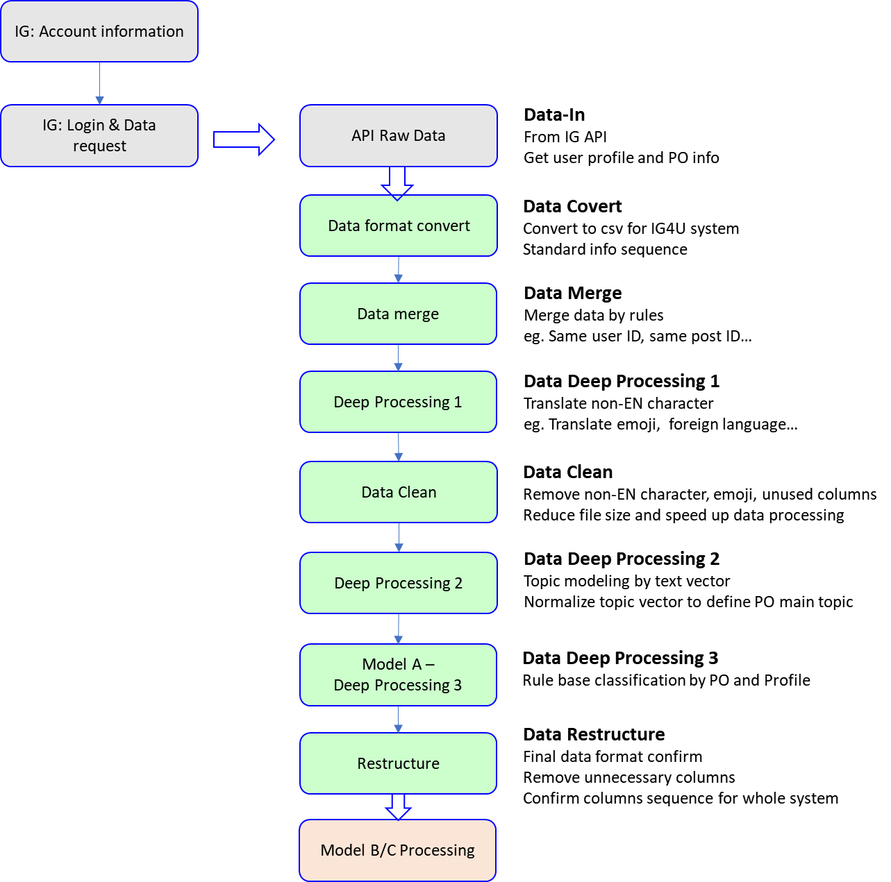

*Figure 6. Process flow for data preparation during production phase*

## Database Structure

For the beta version of IG4U, the user Instagram data for the session are stored as CSV files. Data structure after deep processing is as shown below.

*Table 2. Data Structure after deep processing*

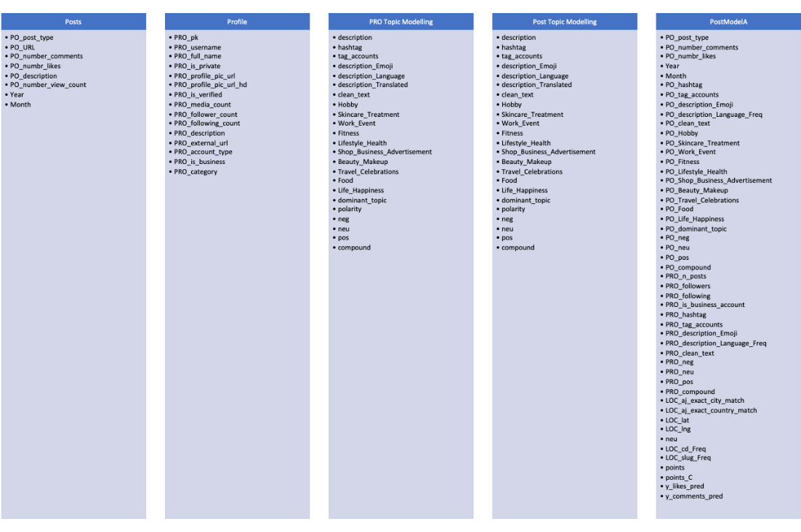

# System Design

## Architecture Overview

There are two system architectures in our project which are used for model development and production respectively. The two system architectures are discussed below.

**System Architecture for Model Development**

The system architecture used for model development is as shown in Figure 7. It consists of 3 different models. Model A is a rule-based model which is designed based on exploratory data analysis and human observations. Model B and C are trained with the processed Instagram dataset for Instagram profile analysis as well as performance prediction respectively. The details of the models will be discussed further in Section 4.2 (Knowledge Engineering).

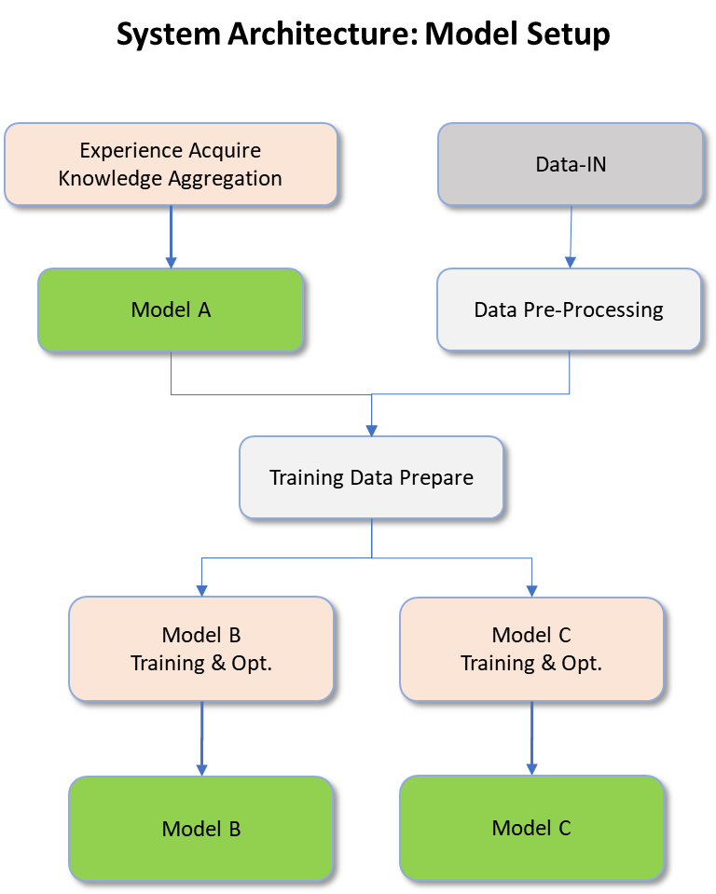

Figure 7. Overall System Architecture Model Setup

**System Architecture for Production**

The system architecture for the production is as shown in Figure 8. As shown in the architecture, the system has incorporated an Instagram login function which would search and download the user’s Instagram data. The downloaded profile and post data will be used for analysis and recommendation using the 3 models developed earlier. Furthermore, the system will separate output into two web version depends on user account type – free or paid.



Figure 8. System Architecture for Production Phrase

## Knowledge Engineering

There are a total of three different models in this project which serve different purpose. Model A is a rule-based model used for data pre-processing and feature engineering. Model B is a clustering model used for user performance evaluation and recommendation. Lastly, model C is a prediction model to predict the number of likes and comments for an Instagram post. The design and development of these three models will be further elaborated in this section.

### Model A: Rule-based Model

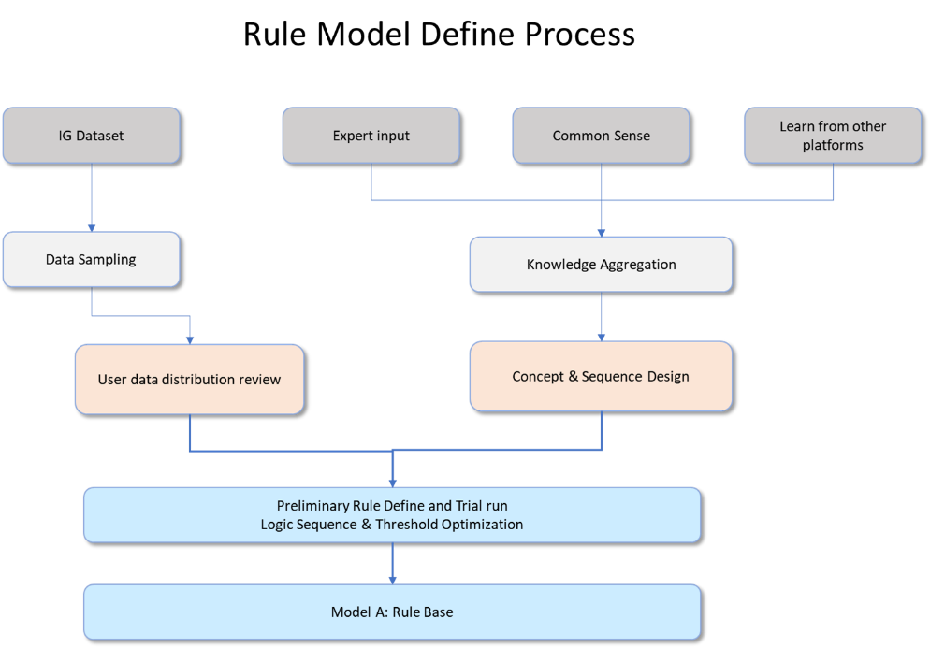

Figure 9. Flowchart for the setup of Model A

Model A is a rule-based model in the IG4U system which was generated from domain knowledge to extract meaningful features from the Instagram dataset. This implicit ranking methodology was created to improve the predictions and association rules accuracy. The output of the model is an additional points column allocated based on defined rules. The general sentiment is that more points will be allocated to an Instagram post which is more popular and higher credibility. The flowchart for the setup of the model is as shown in Figure 9. To ensure that the rules defined in this model are logical and practical, exploratory data analysis and consultation with domain experts were conducted.

**Exploratory Data Analysis**

The frequency distribution for the 200k Instagram post dataset were plotted in histograms as shown in Figure 10 to Figure 13. From the distribution of the number of likes, comments, followers and posts, the trends (e.g. maximum, minimum) of these key parameters could be observed. These values aid in the definition of the rules.

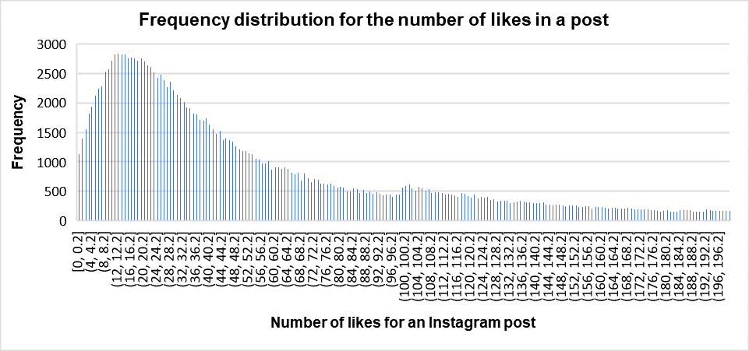

Figure 10. Histogram showing distribution of the number of likes in the dataset

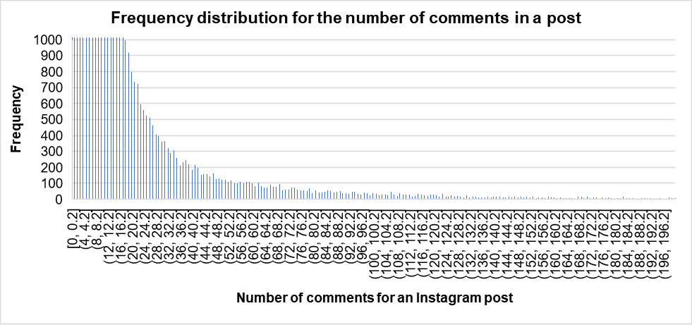

Figure 11. Histogram showing distribution of the number of comments in the dataset.

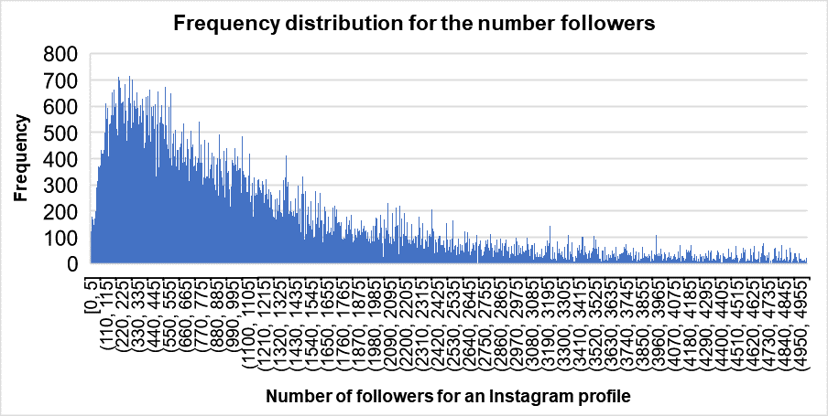

Figure 12. Histogram showing distribution of the number of followers in the dataset

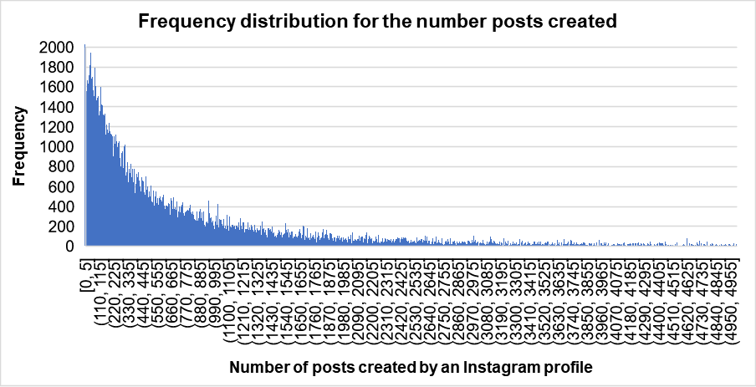

Figure 13. Histogram showing distribution of the number of profile posts in the dataset

**Consultation with domain experts**

Most of the project team members are avid users of Instagram, hence are familiar and have basic understanding of the platform. Furthermore, the team has also spoken to marketing experts to gain insights on industry practices. It was noted that a high number of posts in a short time frame is a sign of abnormal activity while typical users should have regular activities reflected with the reasonable number of posts and comments. On the other hand, popular accounts should have significant numbers of followers, as well as likes and comments for most of their posts. Furthermore, an Instagram account being tagged as business account should be more trustworthy, while an account with multiple negative comments or descriptions tends to be unreliable. This knowledge, gained from domain experts, coupled with common sense and basic user knowledge of social media platforms form the basis of rule-based model A.

**Rules definition**

The defined rules in model A are tabulated in Table 3. It is worth noting that having model A in the data pre-processing is critical in improving the accuracy of the model C downstream, as the points column is one of the key features used in training the prediction model.

Table 3 Defined rules for model A

|  |  |  |  |  |  |  |
| --- | --- | --- | --- | --- | --- | --- |
| Rule No. | Condition 1 | Condition 2 | Condition 3 | Condition 4 | Condition 5 | Allocated points |
| 1 | POST compound >=0 | post >20 | Follower >100 | Like >10 | Comment >5 | 0.1 |
| 2 | POST compound >=0 | post >50 | Follower >200 | Like >20 | Comment >10 | 0.2 |
| 3 | POST compound >=0 | post >200 | Follower >1k | Like >50 | Comment >20 | 0.3 |
| 4 | POST compound >=0 | post >500 | Follower >1k | Like >100 | Comment >50 | 0.4 |
| 5 | POST compound >=0 | post >1000 | Follower >2k | Like >1000 | Comment >100 | 0.5 |
| 6 | POST compound >=0 | post >1000 | Follower >10k | Like >10k | Comment >200 | 0.6 |
| 7 | POST compound >=0 | post >2000 | Follower >100k | Like >100K | Comment >1000 | 0.8 |
| 8 | POST compound<0 | post >50 | Follower >50 |  |  | -0.2 |
| 9 | POST compound<0 | post >500 | Follower >1k |  |  | -0.5 |
| 10 | Is Business account |  |  |  |  | +20% |

### Model B: Clustering

Model B adopted pre-processed data combined with IG4U main user database grouping information to build the second model in IG4U application. The process for the building of the model is as described below.

Prior to building the model, data pre-processing steps were performed. This include data merging, data cleaning, topic modelling (as illustrated in chapter 3), followed by rule-based implicit points system (Model A) for better training performance.

The objective of the model B is to identify various recommendations and score the recommendations based on 3 millions records dataset.

To achieve this we have performed following actions:

1. Compute impression rate for the Instagram page.
2. Identify which cluster with respect to the 3 million records the page belongs to based on the impressions.
3. Consistency : How many posts that the profile user needs to post for traction.
4. Hashtags: Identify ideal hashtags that belongs to top 3 topic performance for the page through content based association ruling. Rating for the hashtags retrieved through rank modelling.
5. Account tagging: Identify famous accounts to tag that belongs to top 3 topic performance for the page through content based association ruling. Rating for the hashtags retrieved through rank modelling.
6. Identify top performing topics based on impressions and recommend those topics.
7. Suggestion on creating an engaging advertisement through Instagram.

The training dataset for model B is the real instagram user data which includes 200K Instagram account and post data. The user account is sorted by impression calculation ( $Impression=100 × \frac{ comment × likes}{follower}$) to determine user performance for user grouping. Finally, users are grouped based on similarity (KNN for deep precessed description & post data), and set same performance users as one group for further processing. Model B will integrate with Model C for all-encompassing user data analysis, predictionm, as well as providing recommendation to promote the account effectively.



Figure 14 Model B Process Setup Overview

### Model C: Prediction by RF

The number of likes and comments are the key indicators of the outreach and interaction of an Instagram post. In our application, model C is a prediction model for these two key indicators. The flowchart, as shown in Figure 15, outlines the process flow for the training of this prediction model.

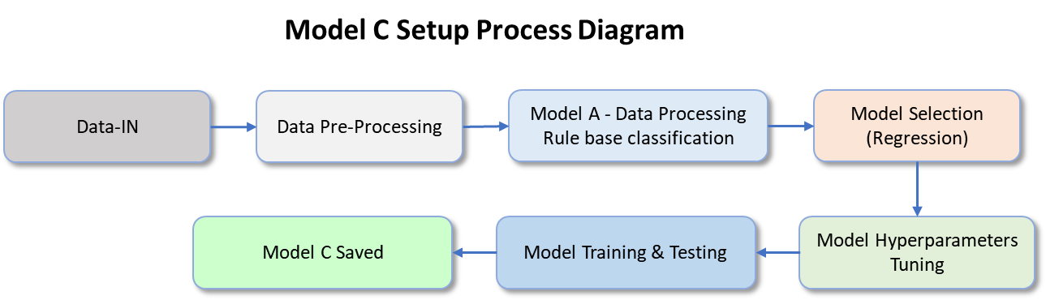

Figure 15. Flowchart for the setup of Model C

The training of a predictive model is an iterative process which involves experimentation, fine-tuning, and careful monitoring to achieve the best results. During the training of the model, the following key steps were considered.

1. Data preparation
2. Choosing of right algorithm
3. Fine tuning of model

As discussed in Section 4.2.1, feature engineering was performed in model A to create a new variable (i.e., points allocated by the rules defined by SME). 6 different versions of the rules were experimented with to determine the effect on the model accuracy. For this comparison, random forest regression model and root mean square error (RMSE) are used as the machine learning algorithm and evaluation metric respectively. The results are tabulated in Table 4. It has been observed that there is minimal difference in the prediction results for the models trained using the points derived by the different set of rules. Nonetheless, model trained with points C has the lowest RMSE and will be used for our model training.

Table 4. Scoring matrix for random forest regression model using different points column as input data

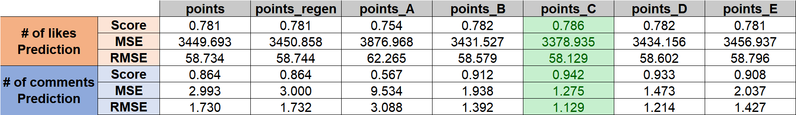

In addition, selecting the appropriate machine learning algorithm is another critical step during model training. There are several regression models under consideration, which include linear regression, polynomial regression, random forest regress, etc. To determine the most suitable regression model for our application, models were trained and evaluated for each of the regression model. The random forest regression model which yields the lowest RMSE, as shown in Table 5, will be used for our model training.

Table 5. Scoring matrix for different regression model

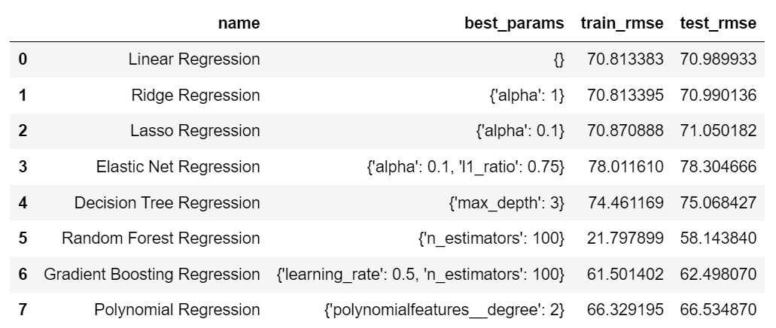

Lastly, grid search cross-validation (grid search CV) was performed to find the best hyperparameter values for the random forest regression model. To determine hyperparameter grid (i.e., set of possible values for each hyperparameter), individual hyperparameters was tested with a range of values. An example is as shown in Figure 16. The range of values which yield the better accuracy will be added to the hyperparameter grid for grid search CV tuning.

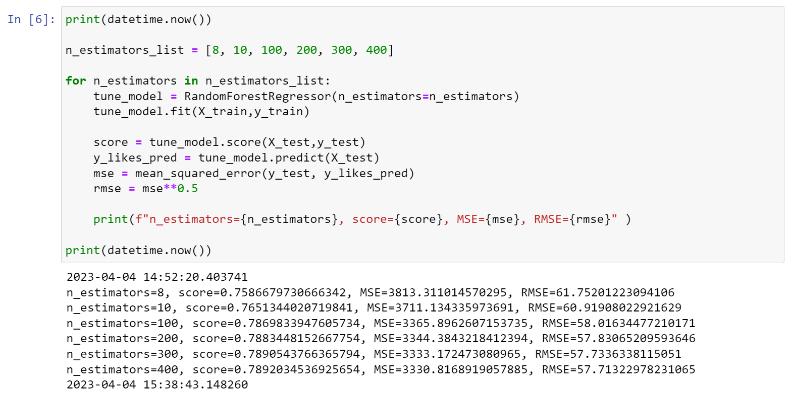

Figure 16. Checking of model accuracy over a range of n_estimators values

The hyperparameters considered for tuning include *n_estimators, criterion, bootstrap and min_samples_split*. Snippets of the code performing grid search CV are shown in Figure 17 and Figure 18. The model score for number of likes and comments prediction are 0.77 and 0.94 respectively.

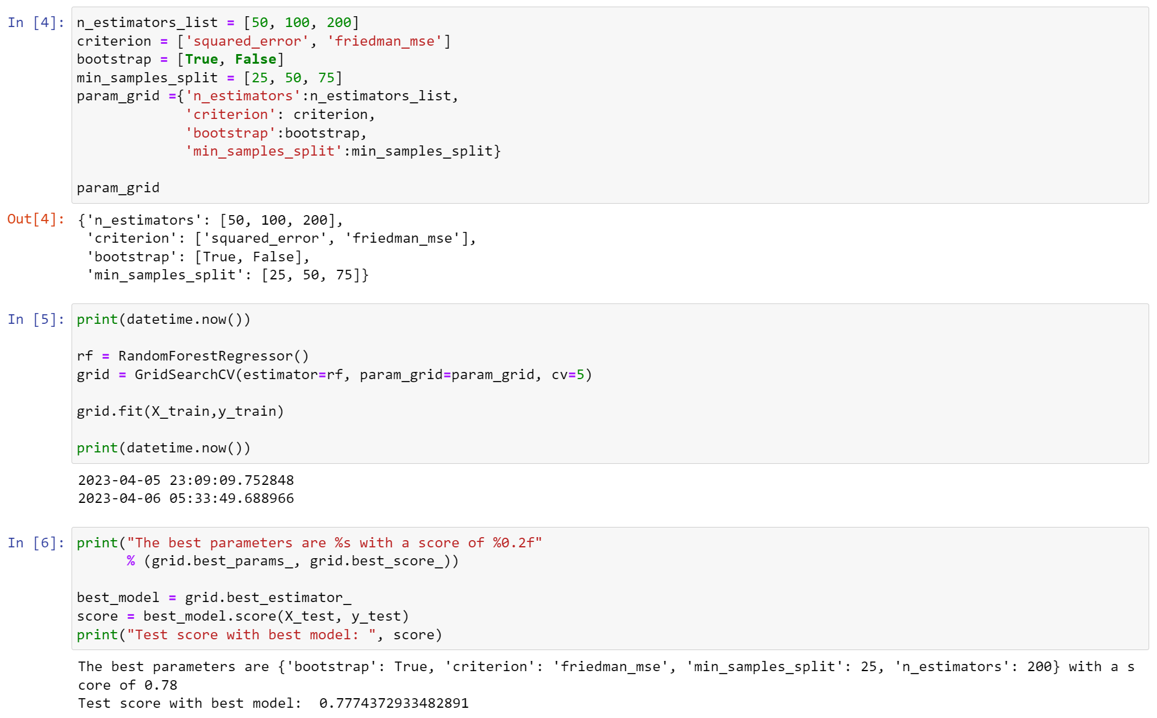

Figure 17. Snippet of code performing GridSearchCV to find best parameters for prediction of number of likes

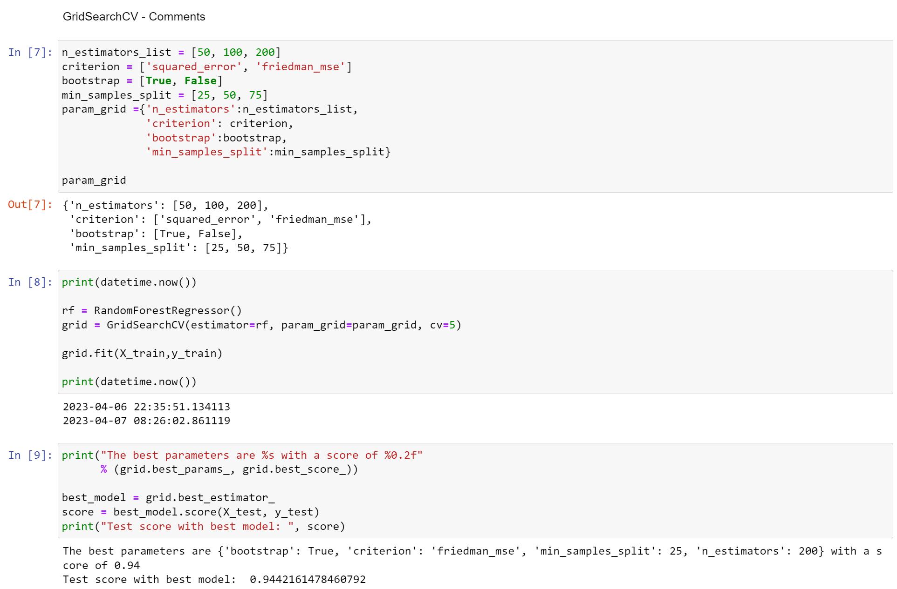

Figure 18. Snippet of code performing GridSearchCV to find best parameters for prediction of number of comments

## User Interface

During production mode, Instagram user account data will be downloaded to IG4U system and be processed by data deep processing as well as the 3 models discussed earlier. The processed data are then integrated with account profile, post, analysis, prediction and IG4U DB grouping reference data for WEB publisher. The web output is based on the type of account which the user has subscribed to – free or paid. As such, once system has identified the user account type from IG4U SQL DB, system will decide web version and display for user review.



*Figure 19 Final User Interface System Design*

**Login Logic Illustration**

Once the user has key in the login information on the login wed UI, the information will be sent to the cloud DB for verification. If the user ID and password successfully match with an existing user account, the system will switch to Instagram API to fetch user profile and post information on Instagram. However, if system is unable to match login details with existing user account, the system will request for new user registration. After user data input, system will record it in cloud DB, followed by a same IG API login procedure.



Figure 20. User Interface's Login system

**IG4U System User Database**

IG4U deploys a cloud DB (Elephant SQL, an amazon cloud DB service) to save and verify user information, which is safe and convenient for multiple-user system maintaining. Detailed information as shown in *Figure 21*.

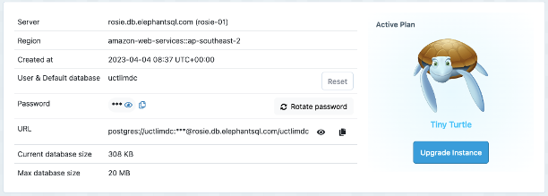

*Figure 21. Elephant SQL employed in IG4U*

**IG4U Web UI example for illustration**

IG4U Web Login

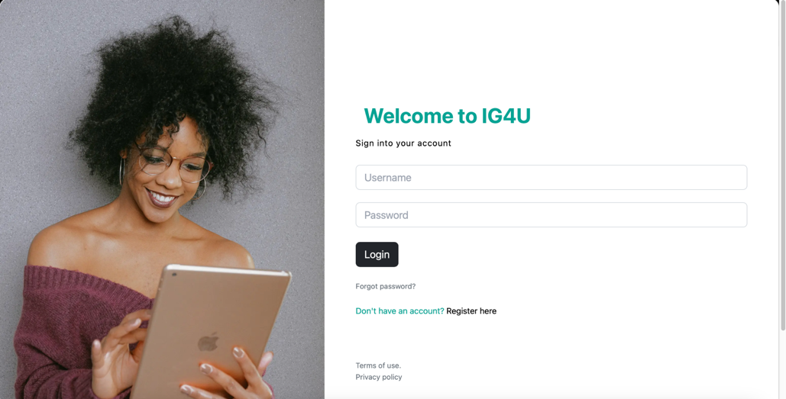

Figure 22. User Interface Login page

Here is the test account for IG4U login. (You will need to register an account if you are analysing the actual Instagram profile)

*Table 6 Testing account for IG4U login*

|  |  |
| --- | --- |
| **Field Name** | **Value** |
| **Username** | test |
| **Password** | 123456789 |

IG4U Registration

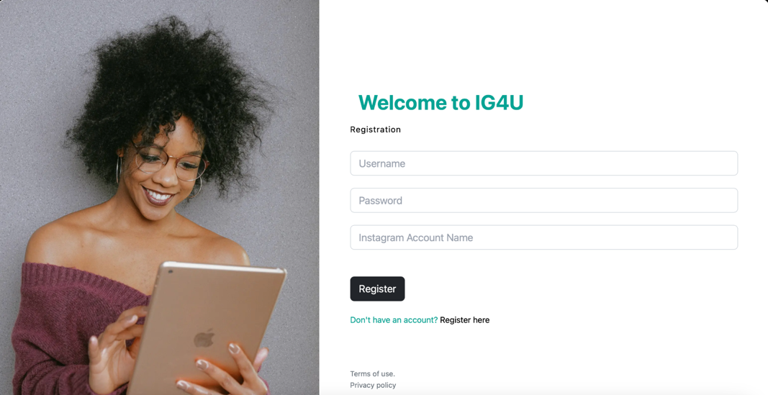

*Figure 23. User Interface Login & Registration page*

*Table 7. Input fields for IG4U registration page*

|  |  |
| --- | --- |
| **Field Name** | **Value** |
| **Username** | Username that you will use to login to IG4U Password |
| **Password** | Password |
| **Instagram Account Name** | Input Instagram account name that you would like to analyse.  In case you do not have any Instagram account. You may use our test account:   1. Archieplutowaggingtails 2. khushboo_sewak 3. doggodorable 4. gov.sg 5. danceincorporated 6. floraisonstudio |

IG4U Forget Password

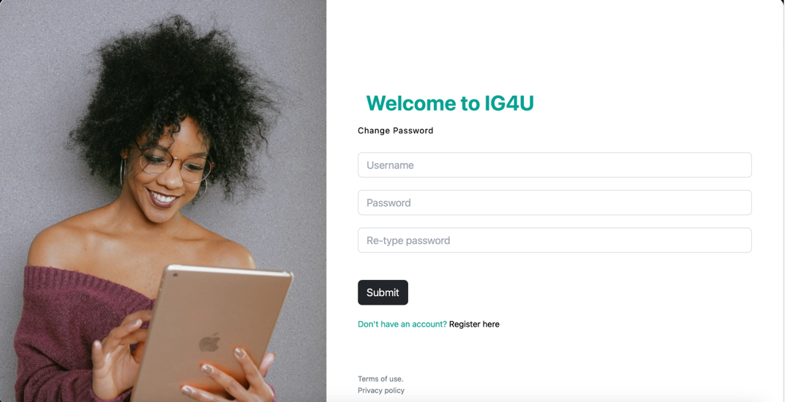

*Figure 24. IG4U forget password page*

*Table 8. Input fields for the forget password section*

|  |  |
| --- | --- |
| **Field Name** | **Value** |
| **Username** | Username that you will use to login to IG4U |
| **Password** | Password |
| **Re-type Password** | Password |

Welcome Page



*Figure 25. IG4U Welcome page*

Here are the details of the main page:

*Table 9. Fields for IG4U Main page*

|  |  |
| --- | --- |
| **Field Name** | **Description** |
| Background Image | Displays the photo that received the most impression among all posts from your profile. |
| 1 | Instagram Page Profile Photo |
| 2 | Instagram Page Full Name as registered |
| 3 | Instagram profile has went through data processing and topic modelling. “I am Known for” is what defines the Instagram page. |
| 4 | You can also directly visit your Instagram page by clicking Instagram icon. |
| 5 | Home Page -> will direct you to this screen when you click. |
| 6 | Refresh -> Allows you to refresh the datasets and generating new info from the Instagram. By default, system will fetch the previously generated information that is saved in your local machine. |
| 7 | About -> brings to about page |
| 8 | Fact -> bring to fact page. |
| 9 | Performance -> bring to performance page |
| 10 | Prediction -> bring to Prediction |
| 11 | Recommendation -> bring to Recommendation |
| 12 | Portfolio -> bring to Portfolio |
| 13 | Logout -> logout from IG4U account |

About

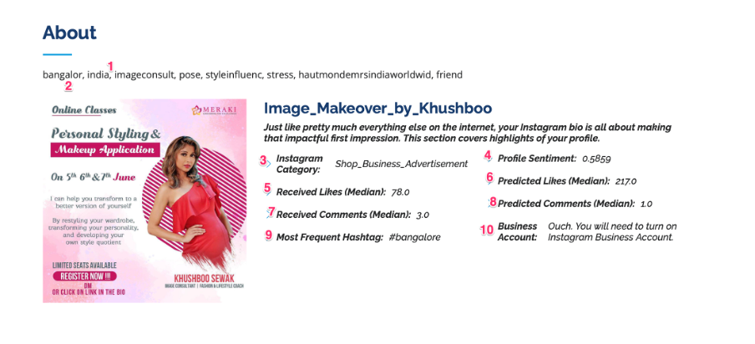

*Figure 26. IG4U About Page*

*Table 10. Features listing of Profile.*

|  |  |
| --- | --- |
| **Field Name** | **Description** |
| 1 | Instagram profile has gone through data processing and topic modelling. “I am Known for” is what defines the Instagram page. |
| 2 | Displays the photo that received the second most impression among all posts from your profile. |
| 3 | Instagram Category -> Instagram profile went through topic modelling with respect to the training dataset of 3 million records and identifies which topic this page belongs too. For example: what is the category of the Instagram page. |
| 4 | Profile Sentiment -> Instagram profile gone through sentiment analysis and identifies the overall sentiment of the profile |
| 5 | Received Likes (Median): Median Likes for the overall posts that the page received. |
| 6 | Predicted Likes (Median): Instagram profiles went through prediction modelling and captures what is the likes that this Instagram page is capable of getting for example: This profile has a potential to receive 217 likes in median. |
| 7 | Received Comments (Median): Median Comments for the overall posts that the page received. |
| 8 | Predicted Comments (Median): Instagram profiles went through prediction modelling and captures what is the Comments that this Instagram page is capable of getting for example: This profile has a potential to receive 217 Comments in median. |
| 9 | Most Frequent Hashtag: the hashtags that the page had used. |
| 10 | Business Account: displays if this Instagram account is business account or not.  Business Account is free. It provides lots of benefits for the reach and impression of the posts. |

Facts

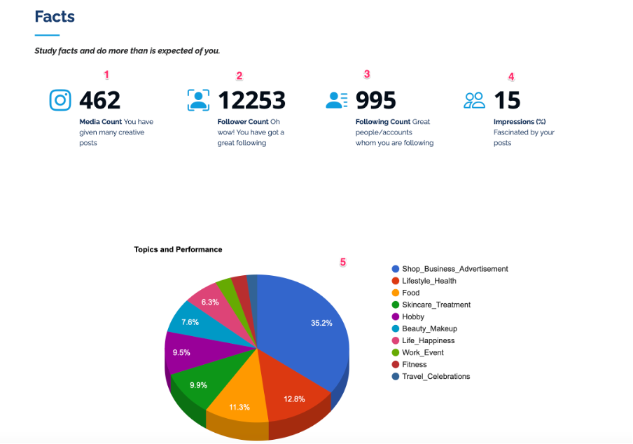

*Figure 27 Facts listing of Account*

*Table 11. Fields listing of Account's facts*

|  |  |
| --- | --- |
| **Field Name** | **Description** |
| 1 | Media Count -> number of posts by the Instagram page |
| 2 | Follower Count -> Total number of followers for this Instagram page |
| 3 | Following Count -> How many accounts that the page is following |
| 4 | Impressions -> Impression of the page  Impression = (total number of likes + comments on Instagram) * 100 / follower count |
| 5 | Topics and Performance:  Instagram page posts went through topic modelling and identifies each post to 10 identified topics. Analysis its impressions for each topic and captures top performing topics.  Note:  Topics are categorised into : PO_Food, PO_Work_Event, PO_Lifestyle_Health, PO_Fitness, PO_Travel_Celebrations, PO_Hobby, PO_Beauty_Makeup, PO_Skincare_Treatment, PO_Life_Happiness, PO_Shop_Business_Advertisement |

Performance

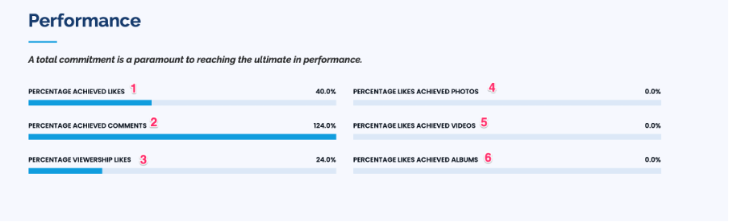

*Figure 28 Account Performance*

*Table 12 Field listing of Account's performance*

|  |  |
| --- | --- |
| **Field Name** | **Description** |
| 1 | Percentage Received Likes -> Target is assumed to be predicted number of likes with respect to 3 million training records (Prediction Modelling). |
| 2 | Percentage Received Comments -> Target is assumed to be predicted number of Comments with respect to 3 million training records (Prediction Modelling). |
| 3 | Percentage Viewership Likes -> Target is assumed to be predicted number of likes based on viewership with respect to 3 million training records (Prediction Modelling). |
| 4 | Percentage Likes Achieved Photos -> Target is assumed to be predicted number of likes by post type photos with respect to 3 million training records (Prediction Modelling). |
| 5 | Percentage Likes Achieved Videos -> Target is assumed to be predicted number of likes by post type videos with respect to 3 million training records (Prediction Modelling). |
| 6 | Percentage Likes Achieved Albums -> Target is assumed to be predicted number of likes by post type albums with respect to 3 million training records (Prediction Modelling). |

Prediction

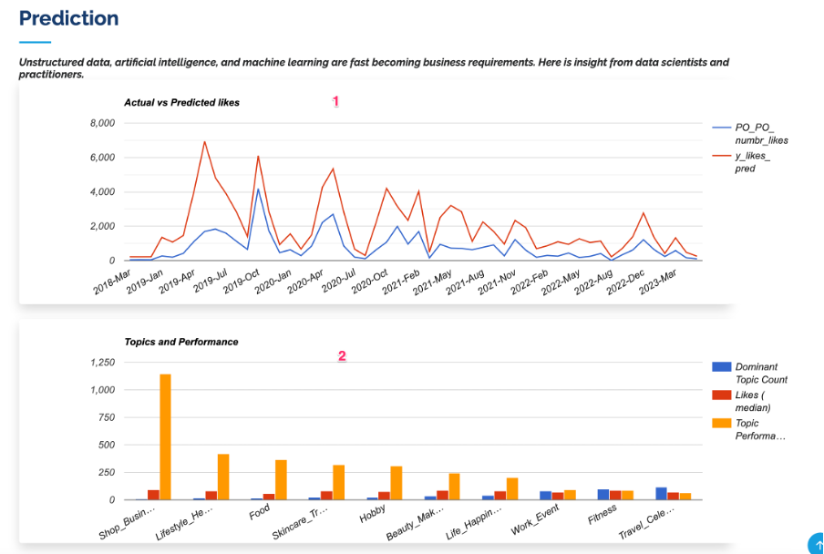

*Figure 29 Account Prediction*

*Table 13 Field listing for account's prediction*

|  |  |
| --- | --- |
| **Field Name** | **Description** |
| 1 | Shows the line graph for the total number of likes vs predicted likes based on each post with the timeframe. |
| 2 | Instagram page posts went through topic modelling and identified each post to 10 identified topics. Analysis its impressions for each topic and captures top performing topics.  Note:  Topics are categorised into: PO_Food, PO_Work_Event, PO_Lifestyle_Health, PO_Fitness, PO_Travel_Celebrations, PO_Hobby, PO_Beauty_Makeup, PO_Skincare_Treatment, PO_Life_Happiness, PO_Shop_Business_Advertisement |

Recommendation

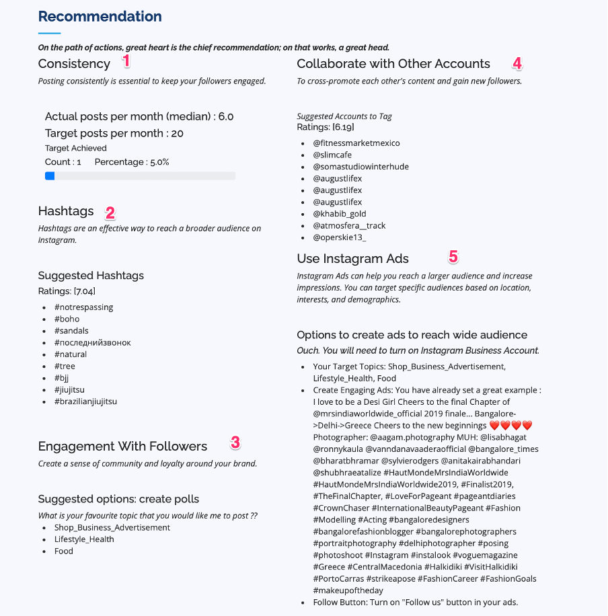

*Figure 30 Account Recommendation*

*Table 14 Field listing of Account recommendation*

|  |  |
| --- | --- |
| **Field Name** | **Description** |
| 1 | Consistency: How many posts that the profile user needs to post for traction. |
| 2 | Hashtags: Identify famous hashtags that belongs to top 3 topic performance for the page through content-based association ruling. Rating for the hashtags retrieved through ranking modelling. |
| 3 | Identify top performing topics based on impressions and recommend those topics. |
| 4 | Account Tagging: Identify famous accounts to tag that belongs to top 3 topic performance for the page through content-based association ruling. Rating for the hashtags retrieved through ranking modelling |
| 5 | Suggestion on creating an engaging advertisement through Instagram. |

Portfolio

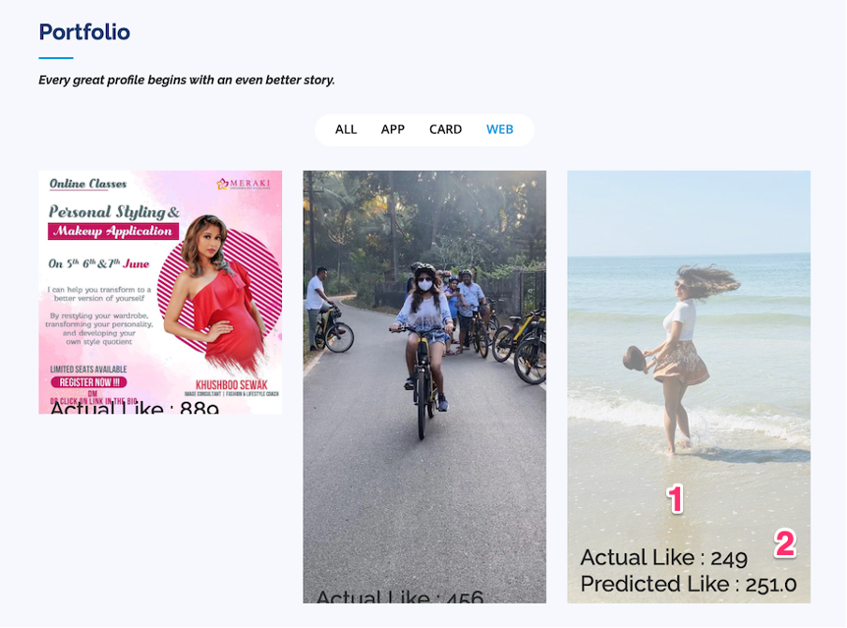

*Figure 31 Account Portfolio*

*Table 15 Field listing for Account's portfolio*

|  |  |
| --- | --- |
| **Field Name** | **Description** |
| 1 | Displays top 9 photos that the Instagram profile received based on the impression |
| 2 | Shows Actual Likes and Predicted likes for the posts based on predicted number of likes with respect to 3 million training records (Prediction Modelling). |

# Application Architecture

Building a layered modern web app architecture helps to identify the role of each component of an application and easily make changes to the corresponding layer without affecting the overall application. It enables to easily write, debug, manage and re-use code.

The three layers of a web app architecture:

* Presentation layer / Client Layer - built using flask and bootstrap
* Application Layer / Business Logic Layer – various aspects of the app such as API and business logic.
* Data Layer – databases services used to store data.

Here is an Web Application Architecture diagram of layers for IG4U Application.

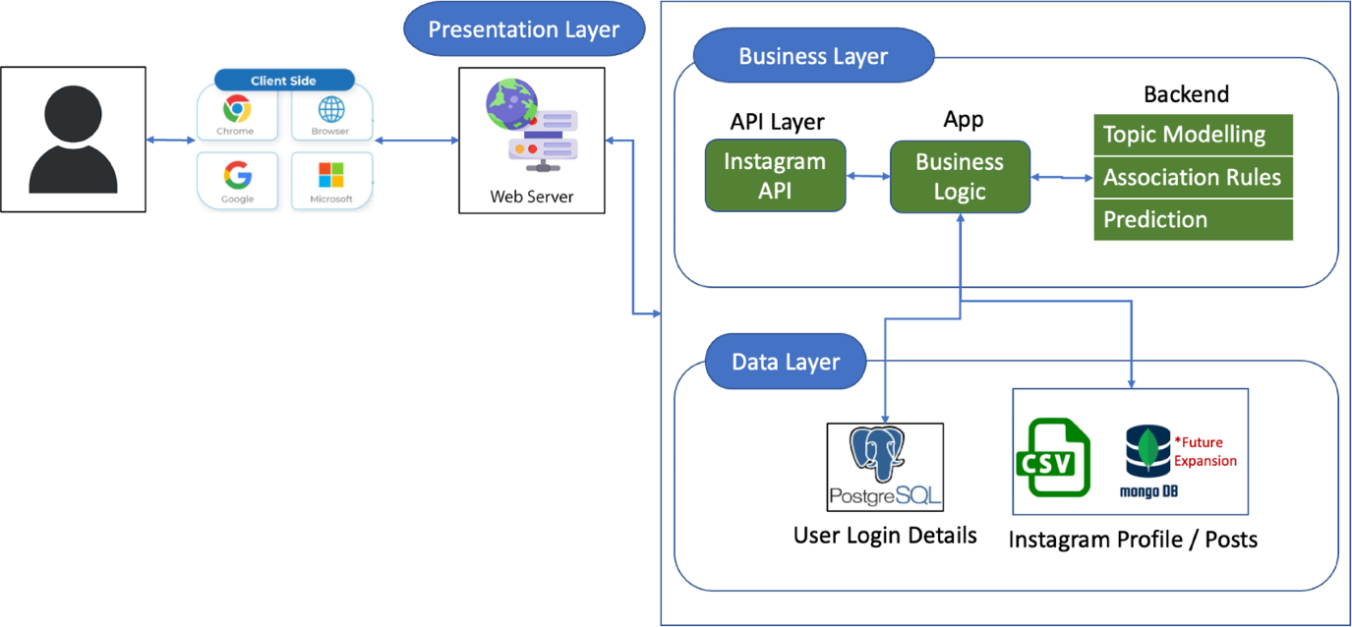

*Figure 32. Web Application Architecture Diagram*

# System / Solution

## System Implementation

After the development of function blocks and integration of all the modules, system tests were performed prior to the beta version release of the application for users.

## System Performance & Validation

The methodology for system test is as listed below:

1. Define test dataset, choose various dataset from database and must cover different user groups, including normal active user, non-active user, popular user, and very popular user.
2. Test the grouping and prediction accuracy
3. Test data integration and web organization
4. Human/Expert final judge for UI output and display format checking
5. Fine tune model or rule to meet Experts’ expectations
6. Test installation and operating under different OS/Hardware environment
7. Test under different user operating preference
8. Continuous Debug then fix software version as beta version release

System test report:

Key items summary after several rounds of bug-fixing

*Table 16 System testing*

|  |  |  |  |  |
| --- | --- | --- | --- | --- |
| **Cat.** | **Criteria/Target** | **Test Items/conditions** | **Test Result** | **Tested by** |
| IG API | IG login functional | Different OS environment | Pass | Zhibiao / Jun Ming |
| Different user with different post, like, follower, language | Pass | Zhibiao / Jun Ming |
| Different operating habit | Pass | Zhibiao / Jun Ming |
| Fetch data successful | Different OS environment | Pass | Zhibiao / Jun Ming |
| Different user with different post, like, follower, language | Pass | Zhibiao / Jun Ming |
| Different operating habit | Pass | Zhibiao / Jun Ming |
| Data processing successful | Different OS environment. | Pass | Zhibiao / Jun Ming |
| Different user with different post, like, follower, language | Pass | Zhibiao / Jun Ming |
| Different operating habit | Pass | Zhibiao / Jun Ming |
| Cloud DB for App User Info | Existing user verify without error | Different OS environment | Pass | Zhibiao |
| Different user account verification | Pass | Zhibiao |
| New user add-in successful | Different OS environment | Pass | Zhibiao |
| Different user account verification | Pass | Zhibiao |
| DB query and maintain without error | All user data query | Pass | Zhibiao |
| DB connected under different OS/Web software | Pass | Zhibiao |
| Login thread check and maintain | Pass | Zhibiao |
| Web integration Function | Install & setup Flask under different environment | MACOS install and setup | Pass | Zhibiao |
| Install under Win10 and setup | Pass | Zhibiao |
| Login without error  Display welcome page under all the environment | Login page and welcome page functional under different OS/Web software/setting | Pass | Zhibiao |
| Integrated software testing | Software Installation without error | Environment test under different OS (MACOS/Windows) & hardware configuration | Pass | Zhibiao |
| Login & Cloud DB access without error | Login, new user registration, user data retrieve, IG account info deliver, and new info write into DB  (Found IG system may block build-in IG account if repeating test, but it is okay for normal user working environment) | Pass* | Zhibiao |
| Correct Display | Web Display no error/distortion under different desktop resolution | Pass | Zhibiao |
| Accurate Model | Data output as model design expectation  (Current model accuracy is good for more than 2/3 of IG account; Plan to further improve it in next version) | Pass* | Zhibiao |
| Data stream processing without error | Test user data stream-in and pre-processing, analysis without error | Pass | Zhibiao |
| Different user account profile & post without error | Test different types of user account, from fresh account, less active account, popular account and business account etc | Pass | Zhibiao |
| Refresh function test for different account | Manually refresh function.  New user auto download function  Existing user refresh  (New user or refresh takes 5-10min, a little bit long but acceptable for beta version; Plan to improve code efficiency to speed up download and data process in next version) | Pass* | Zhibiao |

# Real World Implementation

To validate the usefulness of IG4U, the group has always been eagerly waiting to test our application in a real-world situation. There are various processes that we had put into place for this application. Due to time constraints, we have chosen 1 sponsor among many that will have impact on the application.

Sourcing of sponsor criteria:

1. An influencer who promotes and markets various products.
2. Medium user base followers
3. Understands social media branding techniques

## Introduction of sponsor



*Figure 33 Portraits of sponsor Khushboo Sewak*

Khushboo Sewak works at Deloitt as financial consultant in the day, works as social media influencer in the evenings and image consultant at Panache Academy on the other days. As an image consultant at Panache Academy (https://www.panacheacademy.com/) she upgrades airlines staff on their stylings and conduct, consults and coach Miss and Mr India aspirants. She has also been awarded 2nd runners up, south zone- Haut Monde Mrs India Worldwide 2019. She has been in social media influencing industry since 2016.

Instagram Page: [*https://www.instagram.com/khushboo_sewak/*](https://www.instagram.com/khushboo_sewak/)

As a social media influencer, she works with various beauty product promotions. Thus impressions, reach and tractions are crucial aspect of her Instagram profile.

Khushboo says “The biggest challenge is to understand followers' interests and how to utilize 12k plus followers to attain traction. Instagram provides insights for business accounts but that provides insufficient insights on the content itself”.

Prior to IG4U application usage, Khushboo had 11.2k followers and median of 50 likes for her posts. Our objective is to increase the followers and impression with the help of IG4U recommendation.

## Insights to Khushboo Sewak profile

1. 11.2k followers and median of 50 likes for the posts
2. IG4U has identified her profile is about bangalor, india, imageconsult, pose, styleinfluenc, stress, hautmondemrsindiaworldwid, friend.
3. Her profile generates positive sentiment among her followers.
4. The posts that give good impression are topic Shop_Business_Advertisement, lifestyle health and food.
5. Her most frequent hashtag is #Bangalore.
6. She posts average of 5 times in month since the beginning of the time. But roughly about 10 posts a month in the recent times.
7. Her impressions rate is rather surprising to 13%. She has 11k of followers, however the reach has been average scale.
8. IG4U prediction model (based on 3 million Instagram profiles/posts) reflects that the profile attains only 30% of the potential likes and 120% of the potential comments.
9. Viewership is at 20% of her followers.
10. Profile post type albums creates more traction compared to photos and videos.
11. Instagram page is professional account but not business account.

## IG4U Recommendation

After reviewing the profile IG4U came up with following recommendations.

1. Consistency: Increase the number of posts to 20. IG4U also provides a scale to display how much of the target has been achieved.
2. Hashtags: Hashtags is one way of reaching to people of similar interests. Based on the identified top 3 topics (Shop_Business_Advertisement, lifestyle health and food) and the 3 million Instagram profile/post that we had used for the training, IG4U recommends some hashtags such as that gives a starting point:

* #notrespassing
* #boho
* #sandals
* #последнийзвонок
* #natural
* #tree
* #bjj
* #jiujitsu
* #brazilianjiujitsu

1. Collaboration with other accounts: Collaboration helps to reach diversified customers with similar interests who is not aware of the page however customers might be interested in. This helps to introduce the Instagram page with people of similar interests. Based on the identified top 3 topics (Shop_Business_Advertisement, lifestyle health and food) and the 3 million Instagram profile/post that we had used for the training, IG4U recommends some collaborative such as that gives a starting point:

* @fitnessmarketmexico
* @slimcafe
* @somastudiowinterhude
* @augustlifex
* @augustlifex
* @augustlifex
* @khabib_gold
* @atmosfera__track
* @operskie13_

1. Engagement With Followers; Engagement creates a sense of community and loyalty around your brand. It is recommended to start off with a poll on the top 3 topics (Shop_Business_Advertisement, lifestyle health and food) that is identified by IG4U.
2. Instagram ADs:
   * Turn on Instagram business account and it is free.
   * When promoting or marketing various products post in advertisement. This option enables to reach to wider range of audiences.
   * There is also an option to ingress follow button on the advertisement ensures reach of your account to all levels of Instagram users.
   * Suggested a sample of an engaged ad from the same profile by identifying the maximum reach of the post.

## IG4U recommendation performance

We have arranged for a demo with Khushboo on various recommendations and followed up with her on traction of the Instagram page over a period of month.

Summary of the performance:

1. Instagram followers reached 12k from 11.2k.
2. Impression reached 15% from 13%.
3. Likes reached 40% of the target from 30%.
4. Median likes reached 78 likes from 50 likes.

## Khushboo on IG4U

Khushboo about IG4U on her own words (transcript from Khushboo’s video on IG4U):

|  |
| --- |
| Speaker 1 (00:00):  Hey guys, this is Khushboo and I'm a fashion and style influencer just want to share a small feedback related to the application. That was shared to me by IG4U team (Zhou, Sujatha, Jun Ming and Bryan) in stuff for you. It was an amazing experience for me to use this application. It helped me a lot to understand my page statistics. I got to know a lot more about my Pace than what I was doing before I use the app.    Speaker 1 (00:31):  So, So to be very Frank, yes, Instagram do, provide a lot of insights, but the insights that I got to know. And the suggestions that I got from IG4U team implementing those, it helped me to increase my followers. It helped me to increase my Impressions, and I have gained a lot more followers. And my videos are having better views now. So, yes, I would definitely like to thank IG4U team for all her    Speaker 1 (01:01):  support. Support and helping me to figure out what my page needs the most. And yes, it's an amazing app. Thank you so much IG4U team. |

*Figure 34 Transcript of Khushboo's review of IG4U*

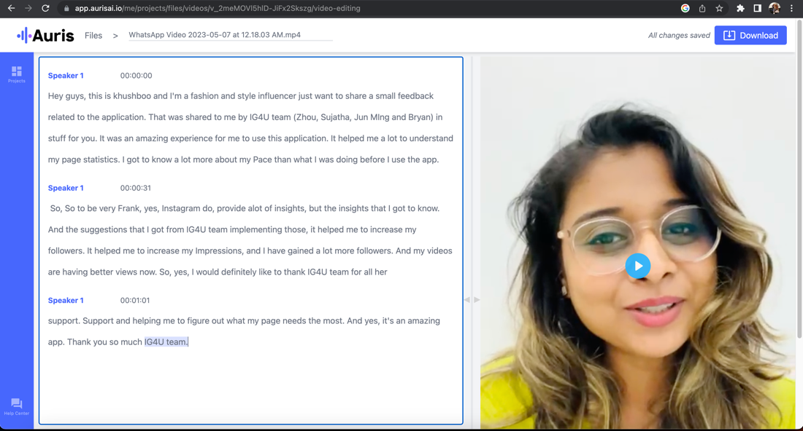

*Figure 35 Screenshot of Khushboo's review of IG4U*

# Conclusion

## Project Conclusion

In this project, all the team members have put in a great amount of effort in the development of IG4U. The hard work, coupled with Sujatha’s skilful coding capabilities, led to the successful development of a recommendation system for Instagram account prediction and promotion.

It has been established that the data could be processed smoothly in IG4U, and all the 3 models worked very well during testing and trial run. Data stream went as expected and API port connected without error. User login and IG data retrieval as desired, system UI worked well during login and data sharing.

The group has finally managed to demonstrate a brand-new system for IG users, especially suitable for business individuals, SME. System verified by development team and trial run users, output as expected. Team got high recommendation from professional agent, which is a surprise for this project.

## Challenges & Suggestion for Future Improvement

Due to the limited resources and manpower, we must focus on main function design and develop at this stage. We did see some potential improvement aspects and we will update in next phase.

1. More features for user data classification, such as IP VS Location, phone number verification etc which may improve confidence level for each user data and good for fine classification.
2. More datasets for model learning to improve Model Accuracy. It is essential to train model by different dataset to fit different user profile/post, so as to cover the variation of target users. Plan to add more features and increase dataset to further optimise model B & C to get better accuracy for all the IG account, especially for recent year IG post style trend. Since current model can cover 2/3 of real IG account while some new account without post or less post, system can not analysis without enough post data or implicit hint, but it is acceptable for beta version. Team plan to design a hybrid recommend system (combine user similarity and item similarity) to check the similarity between new users and target groups for better prediction and recommendation.

At the user target definition stage, team decided to serve for positive attitude users only, that’s why we reduce performance and prediction for those negative comment accounts. Although we plan to block this type of user and refuse to service them, we still show the account analysis result and recommendation for ISS project review. Actually we adopt hard rule and NLP for roughly identification, but we cannot guarantee 100% accuracy at this stage although it is not a big issue for software main target users. Team plan to design a more accurate model after more features add in for training so as to identify such user in next phase and the UI output would be “We are sorry, we cannot serve this account….”

1. More User friendly and fashion UI to fulfil IG style, interactive UI is possible for user data display and prediction in next version.
2. More test under different hardware and OS environments to enhance compatibility
3. Improve code efficiency for IG user data processing and recommendation, current system takes 5-10min for new user or refresh, acceptable for beta version, but still not good enough. Stay tune for our next version, thanks!
4. User verification process with model self-adapt function. It is an advanced function designed for more reliable model. With the input of system admin, it is possible to further improve model accuracy by human experience judgement (improve model fusion weight algorithm by expert input or judgement). Also planned a new function to add new user data into self-training database for system self enhancement. Plan to add in these functions at next version for more accurate and reliable AI system.   
   System design as following,

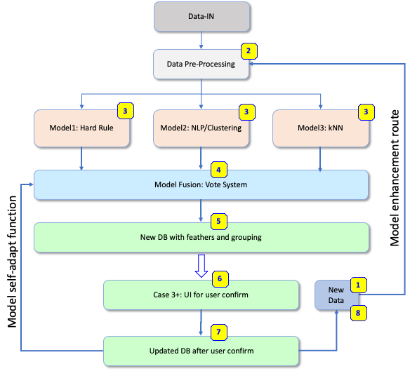

*Figure 36 Future enhancement system concept*

# References

Dave, C. (30 January, 2023). *Global Social Media Statistics Research Summary 2022 [June 2022]*. Retrieved from Smart Insights: https://www.smartinsights.com/social-media-marketing/social-media-strategy/new-global-social-media-research/

Levesque, R. B. (2004). *Knowledge Representation and Reasoning.* Elsevier.

Matthew D. Hoffman, D. M. (2013). *Stochastic Variational Inference.* Retrieved from Journal of Machine Learning Research 14 (2013) 1303-1347: https://www.cs.columbia.edu/~blei/papers/HoffmanBleiWangPaisley2013.pdf

Meta. (2023). *Community Guidelines*. Retrieved from https://help.instagram.com/477434105621119/?helpref=hc_fnav

*Social media channel usage breakdown*. (n.d.). Retrieved from https://www.smartinsights.com/wp-content/uploads/2021/10/Social-media-channel-usage-breakdown.png

Taslaud, G. (3 Feburary, 2023). *Instagram Bots: Should you use Automation in 2023?* Retrieved from https://www.insg.co/en/use-instagram-bots/

Tibshirani, T. H. (2009). *The Elements of Statistical Learning: Data Mining, Inference, and Prediction, Second Edition.* Springer.

# Table of Figures

*Figure 1. The world's most used social platforms* 4

*Figure 2. Key features of the various social media platforms* 4

*Figure 3. Process flow for data preparation during development phase* 10

*Figure 4. Merging of data in the 3 CSV files with a common column* 11

*Figure 5. Cleaning of dataset* 11

*Figure 6. Process flow for data preparation during production phase* 13

Figure 7. Overall System Architecture Model Setup 15

Figure 8. System Architecture for Production Phrase 16

Figure 9. Flowchart for the setup of Model A 17

Figure 10. Histogram showing distribution of the number of likes in the dataset 18

Figure 11. Histogram showing distribution of the number of comments in the dataset. 18

Figure 12. Histogram showing distribution of the number of followers in the dataset 18

Figure 13. Histogram showing distribution of the number of profile posts in the dataset 19

Figure 14 Model B Process Setup Overview 22

Figure 15. Flowchart for the setup of Model C 22

Figure 16. Checking of model accuracy over a range of n_estimators values 24

Figure 17. Snippet of code performing GridSearchCV to find best parameters for prediction of number of likes 25

Figure 18. Snippet of code performing GridSearchCV to find best parameters for prediction of number of comments 25

*Figure 19 Final User Interface System Design* 26

Figure 20. User Interface's Login system 27

*Figure 21. Elephant SQL employed in IG4U* 27

Figure 22. User Interface Login page 28

*Figure 23. User Interface Login & Registration page* 29

*Figure 24. IG4U forget password page* 30

*Figure 25. IG4U Welcome page* 31

*Figure 26. IG4U About Page* 32

*Figure 27 Facts listing of Account* 33

*Figure 28 Account Performance* 34

*Figure 29 Account Prediction* 35

*Figure 30 Account Recommendation* 36

*Figure 31 Account Portfolio* 37

*Figure 32. Web Application Architecture Diagram* 38

*Figure 33 Portraits of sponsor Khushboo Sewak* 41

*Figure 34 Transcript of Khushboo's review of IG4U* 44

*Figure 35 Screenshot of Khushboo's review of IG4U* 45

*Figure 36 Future enhancement system concept* 47

*Figure 37 Interview Questions to gain marketing insights.* 53

*Figure 38 Survey questions for population study* 54

*Figure 39 The graphical model representation of Latent Dirichlet allocation* 65

# Table of tables

Table 1. Identification of topic from topic modelling 12

*Table 2. Data Structure after deep processing* 14

Table 3 Defined rules for model A 20

Table 4. Scoring matrix for random forest regression model using different points column as input data 23

Table 5. Scoring matrix for different regression model 23

*Table 6 Testing account for IG4U login* 28

*Table 7. Input fields for IG4U registration page* 29

*Table 8. Input fields for the forget password section* 30

*Table 9. Fields for IG4U Main page* 31

*Table 10. Features listing of Profile.* 32

*Table 11. Fields listing of Account's facts* 33

*Table 12 Field listing of Account's performance* 34

*Table 13 Field listing for account's prediction* 35

*Table 14 Field listing of Account recommendation* 36

*Table 15 Field listing for Account's portfolio* 37

*Table 16 System testing* 40

*Table 17. Market competitors comparison* 55

# Appendix

## Interview with a Marketing Professional

An interview was conducted with a marketing professional, Seah Jun Hui, who has more than 5 years of experience in the marketing industry in various organisations such as M1 Limited, CIMB and HSBC. A phone call discussion was initiated to better understand her views and experience of using Instagram as a marketing tool in her role, followed by an email to capture the interview reply. The email reply from Jun Hui is as attached below.

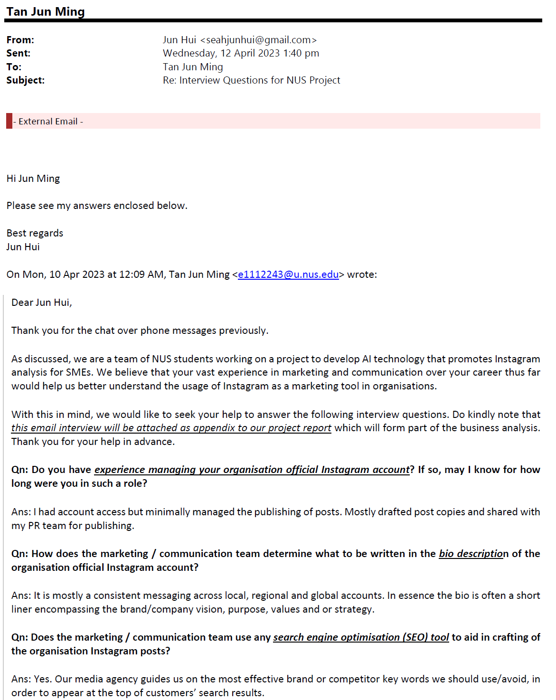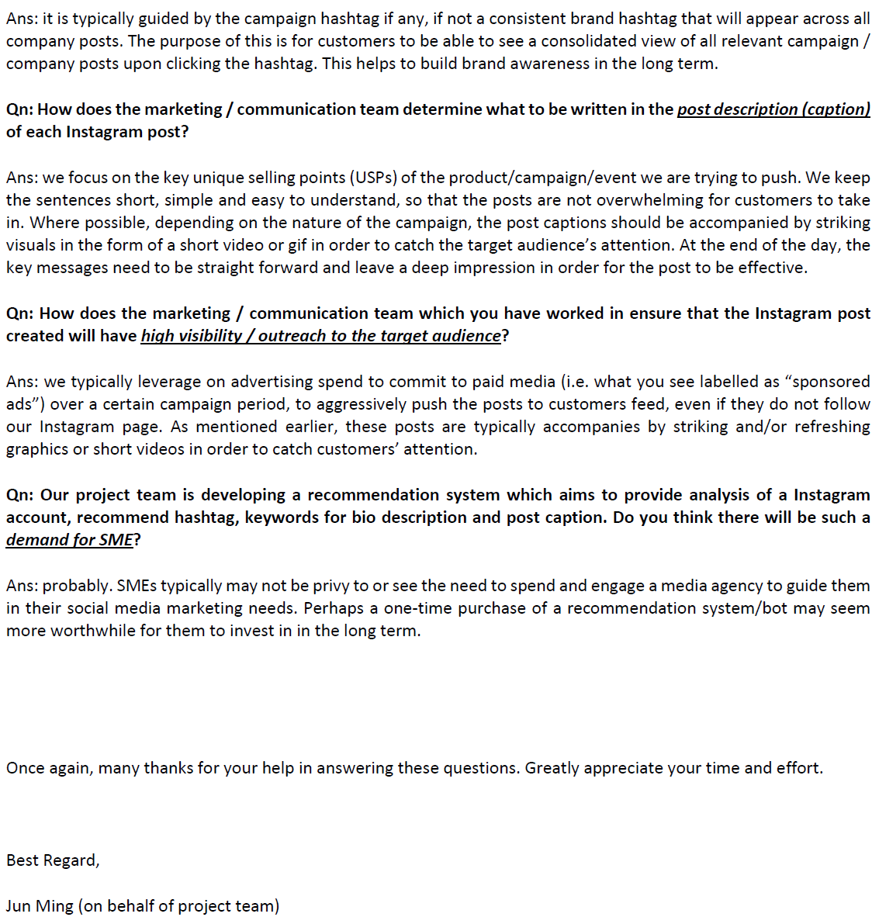

*Figure 37 Interview Questions to gain marketing insights.*

## Survey Questions for population study

The following is the questionnaire map for population study to find out the realistic situation of both business users and non-business users with or without Instagram account, and their challenges faced.

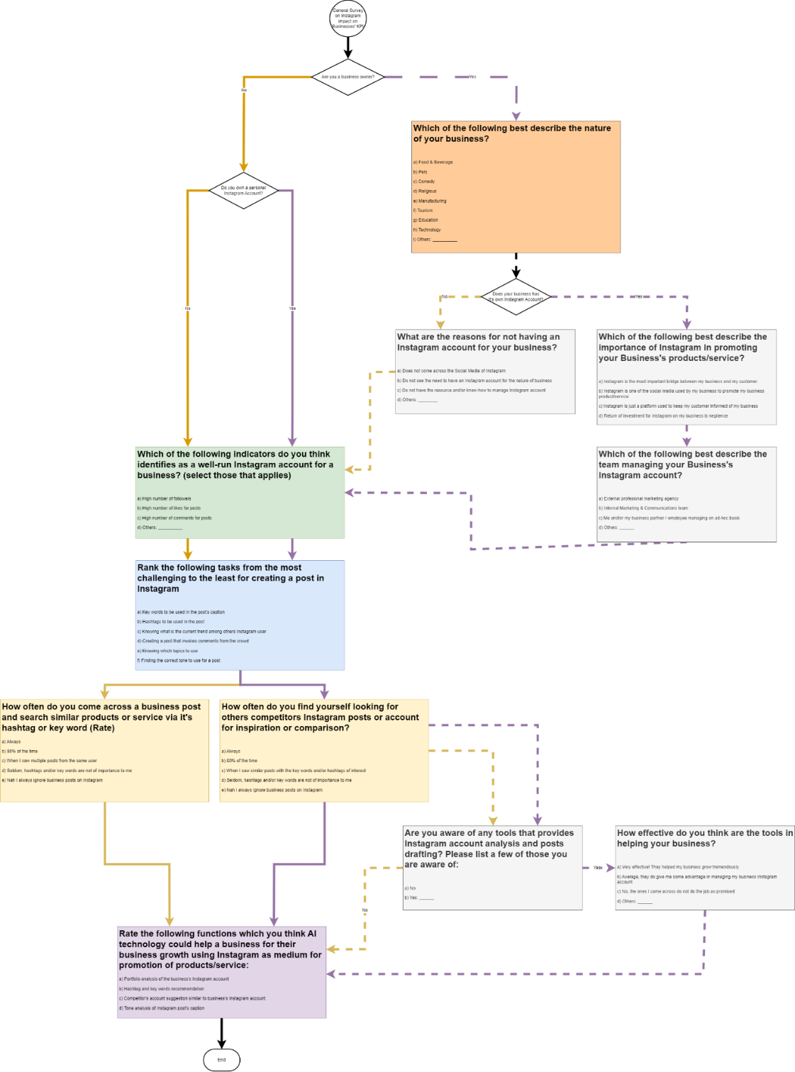

*Figure 38 Survey questions for population study*

## Market Competitors

The following are the list of competitors closest to our product, and their key features, product pricing, and reviews are stated here for a quick analysis.

*Table 17. Market competitors comparison*

|  |  |  |  |  |  |  |  |  |
| --- | --- | --- | --- | --- | --- | --- | --- | --- |
| S/N | Platform | URL | Pricing | Key Features | Customer Location | Reviews | Review ratings | Summary |
| 1 | iconosquare | https://www.iconosquare.com/ | 70SGD/Month , 113SGD/Month, 198SGD / Month | Analytic Dashboard, Listen (Spy competitors) | Europe, USA, Canada, Australia | <https://www.getapp.sg/reviews/2048445/iconosquare> | 4.4/5 (49) | Good: Good User Interface, Competitors benchmarking are useful   Bad: Competitor analysis took longer than 24 hours to generate |
| 2 | Pallyy | https://pallyy.com/ | Free, $15/Month | Instagram Analytics (See Competitors), Scheduling |  | <https://www.capterra.com/p/235294/Pallyy/reviews/> | 4.8/5 (41) | Good: Affordable, all features in the same place  Bad:  Issue with media uploading |
| 3 | kontentino | https://www.kontentino.com/ | 62SGD/ Month, 141SGD/Month, 256SGD / Month | Publishing, **Analyse (Social Media Benchmark)** |  |  | 4.5/5 (159) | Good: Calendar features to post for approval at client side. |
| 4 | brandwatch | https://www.brandwatch.com/ |  | Publish, Advertise, Measure, Benchmark, influence (Discover influencer), Listen ( Monitor Social Web for insights) |  |  | 4.2/5 (211) | Good: Able to draw out sentiment and context  Bad: Insights and reporting element is not fully developed. |
| 5 | Path Social | https://www.pathsocial.com/ | $69/Month, $49/Month | AI Profile Reeview, Influencer Shout Out, Relevant Hashtag, Real-Time Analytics |  |  | 2.9/5 (199) | Bad: Recommending a lot of fake followers |
| 6 | Ai Grow | https://aigrow.me/ | $45, 103, 90, 77 | Analytical Report, Organic Real followers: Hashtags, Competitors, Locations, Gender Targeting |  |  | 4.6/5 (443) | Good: Easy to use, effective and grow follower base with the app |
| 7 | NapoleonCat | https://napoleoncat.com/ | $25, 63 | Analytic - Competitor analysis, Benchmark Analytic | SME, Enterprise, eCommerce |  | 4.7/5 (46) | Good: Able to coordinate all social profiles from one dashboard |

## Project Proposal

**GRADUATE CERTIFICATE: Intelligent Reasoning Systems (IRS)**

**PRACTICE MODULE: Project Proposal**

|  |
| --- |
| **Date of proposal:**  18 February 2023 |
| **Project Title:**  ISS Project – IG4U--Intelligent Instagram Profile Analysis System |
| **Sponsor/Client:** *(Name, Address, Telephone No. and Contact Name)*  Institute of Systems Science (ISS) at 25 Heng Mui Keng Terrace, Singapore  NATIONAL UNIVERSITY OF SINGAPORE (NUS)  Contact: Mr. GU ZHAN / Lecturer & Consultant  Telephone No.: 65-6516 8021  Email: [zhan.gu@nus.edu.sg](mailto:zhan.gu@nus.edu.sg) |
| **Background/Aims/Objectives:**  The proposed Intelligent User Data Analysis System will analyse user profile and post for topic modelling and followed by account confidence level assessment and similar user grouping. Instagram dataset will be adopted for project & software demo. The model can be used for IG account deep analysis then generate recommendation to improve active users’ performance so as to enhance their business. |
| Requirements Overview:   * Quick Learning & Research ability * Construction of database * Decision modelling * Hybrid sub-system * User interface * Programming ability * Integration of frontend and backend components * Troubleshooting and end-to-end testing * System integration ability * Teamwork & Project Management for on-time delivery |
| Resource Requirements (please list Hardware, Software and any other resources)  Hardware proposed for consideration:   * CPU/GPU for NLP Process and Complex Model Learning   Software proposed for consideration:   * Reasoning systems: e.g., Python, Orange3, etc * DB maintain: Elephant SQL, MySQL * Machine learning: e.g., Orange3, NLP * Cloud computing/server: e.g., Databricks, Google Colab etc * Others: Anaconda, scikit-surprise, beautifulsoup, chatterbot, spacy, demoji, translate, …. (pls refer to user guide for full libraries listing) |
| **Number of Learner Interns required: (Please specify their tasks if possible)**  a team of four project members (or individual work upon lecturer approval)   1. Group leader for function & system architecture design, project management 2. Software Eng. for software coding and UI validation 3. 2 team members for business/marketing analysis, data/materials preparation 4. All 4 team members to collaborate for model setup, tuning and optimization, as well as software testing, packaging |
| **Methods and Standards:**   |  |  |  | | --- | --- | --- | | **Procedures** | **Objective** | **Key Activities** | | | **Requirement Gathering and Analysis** | The team should meet with ISS to scope the details of project and ensure the achievement of business objectives. | 1.        Gather & Analyse Requirements | | 2.        Define internal and External Design | | 3.        Prioritize & Consolidate Requirements | | 4.        Establish Functional Baseline | | **Technical Construction** | ·         To develop the source code in accordance to the design. | 1.        Setup Development Environment | | ·         To perform unit testing to ensure the quality before the components are integrated as a whole project | 2.        Understand the System Context, Design | | 3.        Perform Coding | | 4.        Conduct Unit Testing | | **Integration Testing and acceptance testing** | To ensure interface compatibility and confirm that the integrated system hardware and system software meets requirements and is ready for acceptance testing. | 1.        Prepare System Test Specifications | | 2.        Prepare for Test Execution | | 3.        Conduct System Integration Testing | | 4.        Evaluate Testing | | 5.        Establish Product Baseline | |  | | **Acceptance Testing** | To obtain ISS user acceptance that the system meets the requirements. | 1.        Plan for Acceptance Testing | | 2.        Conduct Training for Acceptance Testing | | 3.        Prepare for Acceptance Test Execution | | 4.        ISS Evaluate Testing | | 5.        Obtain Customer Acceptance Sign-off | |  | | **Delivery** | To deploy the system into production (ISS standalone server) environment. | 1.        Software must be packed by following ISS’s standard | | 2.        Deployment guideline must be provided in ISS production (ISS standalone server) format | | 3.        Production (ISS standalone server) support and troubleshooting process must be defined. | |  | |

**Team Formation & Registration**

|  |
| --- |
| Team Name:  ISS-2023-IG4U |
| Project Title (repeated):  ISS Project –IG4U--Intelligent Instagram Profile Analysis System |
| System Name (if decided):  Profile Analysis & Recommend System |
|  |
| Team Member 1 Name:  Zhou Zhibiao |
| Team Member 1 Matriculation Number:  A0269368J |
| Team Member 1 Contact (Mobile/Email):  +65-82985291/zzbjohn@gmail.com |
|  |
| Team Member 2 Name:  Sureshkumar Sujatha |
| Team Member 2 Matriculation Number:  A0269371W |
| Team Member 2 Contact (Mobile/Email):  98800556/E1112242@u.NUS.edu |
|  |
| Team Member 3 Name:  Tan Jun Ming |
| Team Member 3 Matriculation Number:  A0269372U |
| Team Member 3 Contact (Mobile/Email):  83220481/e1112243@u.nus.edu |
|  |
| Team Member 4 Name:  Lim Zhi Jing |
| Team Member 4 Matriculation Number:  A0269638J |
| Team Member 4 Contact (Mobile/Email):  91756609/e1113632@u.nus.edu |
|  |
| Team Member 5 Name: |
| Team Member 5 Matriculation Number: |
| Team Member 5 Contact (Mobile/Email): |
|  |
| Team Member 6 Name: |
| Team Member 6 Matriculation Number: |
| Team Member 6 Contact (Mobile/Email): |
|  |

|  |  |  |
| --- | --- | --- |
| **For ISS Use Only** | | |
| **Programme Name:** | **Project No:** | **Learner Batch:** |
| **Accepted/Rejected/KIV:** | | |
| **Learners Assigned:** | | |
| **Advisor Assigned:**  Contact: Mr. GU ZHAN / Lecturer & Consultant  Telephone No.: 65-6516 8021  Email: [zhan.gu@nus.edu.sg](mailto:zhan.gu@nus.edu.sg) | | |

Additional check for the problem statement:



**Goal:**

User information deep processing and account confidence factor evaluation for high performance model training, finally feed into user performance prediction sub-system, provide high performance user information analysis model

Setup user account deep analysis model and provide account performance enhancement recommendation for individual and Small Medium Enterprises (SME) to boost their business

1. **Is there anyone knows the solution?**

Partially yes. IT Giants like Google, Facebook, Taobao, Tecent etc, have their own IT teams which work on data mining and user behavior analysis. However, their model and data are only used for own business and are confidential for others. As such, there is a need to develop an open-source model which will be beneficial to others.  We basically know some of their rules or analysis methodology, generally we can apply common sense or own experience for basic rule definition. That’s our project start point.

1. **Has relevant data collection?**

Since user account and relevant information are confidential, we cannot get full set of DB. Alternately, we can choose certain public DB (i.e. IG dataset) for model tuning. With the help of our knowledge of big data analysis, feature engineering, modelling, data mining, machine learning & recommendation technology, we can setup own model and review model performance for further tuning. Lastly, we may combine different model output by data fusion function to fulfil system requirement.

Prior to that, we will review data sample carefully, re-organize and deep pre-process dataset so that we can export it with pre-set grouping and unified format. Such data feature engineering work is good for best model choosing and high efficiency model training.

1. **Can simulate/generate relevant data?**

Yes. We can either adopt public DB or use data sampling method for model learning and tuning in future. Also, we can general some dataset for model test if necessary.

## Mapped System Functionalities against knowledge, techniques, and skills of modular courses: MR, RS, CGS

This section comprises of the background study of the models used for this project learnt in this course of study. Most of the models were decided based on the initial starting point of our module for this semester.

In our model C set up, we mentioned in the report earlier that we use Python’s Grid Search CV to determine which of the selected regression models are suitable for our use case.

With various topics covered in our huge database, there is a need to refine and fine tune the topic structure with the most efficient model. this is where Random Forest Regression stands out. the key reason why Random Forest regression stands out is due to its simplicity in tuning and training as compared to others. As quoted in (Tibshirani, 2009) Chapter 17 page 602: “The idea in random forests is to improve the variance reduction of bagging by reducing the correlation between the trees, without increasing the variance too much. This is achieved in the tree-growing process through random selection of the input variables.”

In Python Scikit Learn package, the boosting is known as bootstrapping. This is where the package obtains random samples to train for the model. As stated in the book, Random Forests stabilises at approximately 200 trees. in our training, it obtains a very good data at 100 trees and with bootstrapping.

Another technique used heavily in this project is from the Natural Language Processing aspect. in our project we rely heavily on LDA (Latent Dirichlet Allocation) to provide us with topic modelling and sentimental analysis. LDA is optimised with the use of Stochastic Variational Inference that apply Bayesian nonparametric topic models for our massive data sets. (Matthew D. Hoffman, 2013) Page 21

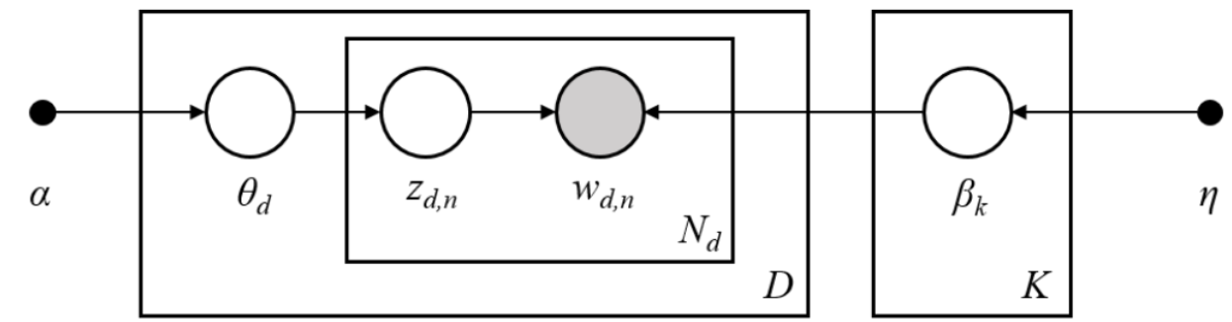

*Figure 39 The graphical model representation of Latent Dirichlet allocation*

Finally, we engaged a forward-chaining reasoning system the uses production rules to represent general knowledge (aka common sense). This allows us to set antecedent conditions to our working memory and group the dataset into different weightage (points) for us to determine the legitimacy of the posts and/or profiles. Using EDA to determine the grouping size of each category, we arrived at the final table as shown in Table 2 Design rule for Webpage display to fire the sequence for our model A. Chapter 7 page 117 (Levesque, 2004)

IG4U system also adopted data pre-processing concept as Reasoning System introduction, deep processing including data merge, data cleaning and feature engineering are necessary for model learning as well as the following data stream.

Human experience is the first thing need to build in as Machine Reasoning introduction, we adopted common sense, expert input as well as dataset sampling analysis result to build a perfect dataset for model B and model C training, achieved good model accuracy after rule base model pre-processing.

Different recommendation concepts are adopted for IG4U system, such as rule-base confidence factor calculation, feeding to model training as well as production phase as an implicit ranking methodology, which we confirmed it is really high efficiency and high accuracy for the recommended output. We also deliberately select key feathers for similar user grouping and adopt impression sorting as recommendation index to provide the most similar user group’s reference data. The ranking & sorting algorithm are confirmed useful and effective in IG4U system.

Hybrid reasoning system is adopted in IG4U system design, in which we integrate topic modelling, rule base model, clustering model as well as Random Forest prediction model for IG user information handling so as to get an acceptable grouping and performance prediction for end customer. Independent sub-system and cooperating expert concepts are practiced in IG4U data processing and reasoning sub-system.

## Installation and User Guide

Refer to IG4U User Guide Document.

## Individual project report

|  |
| --- |
| Team Member 1 Name:  Zhou Zhibiao |
| Team Member 1 Matriculation Number:  A0269368J |
| Team Member 1 Contact (Mobile/Email):  +65-82985291/zzbjohn@gmail.com |
| Main Tasks:  System architecture design  System main function block & data stream integration  Model-A rule-base model design & tuning  System test and debug  Final report & project major material organizing  Co-work for high level system introduction video  Overall project plan, control, and fine tune |
|  |
| Team Member 2 Name:  Sureshkumar Sujatha |
| Team Member 2 Matriculation Number:  A0269371W |
| Team Member 2 Contact (Mobile/Email):  98800556/E1112242@u.NUS.edu |
| Main Tasks:  IG4U coding and assist system design.  Application architecture design  Data pre-processing & Model-B develop.  System backend integration  Video interview & professional comment for IG4U system  User guide for IG4U  Assist final report |
|  |
| Team Member 3 Name:  Tan Jun Ming |
| Team Member 3 Matriculation Number:  A0269372U |
| Team Member 3 Contact (Mobile/Email):  83220481/e1112243@u.nus.edu |
| Main Tasks:  Assist project leader for system design.  Perform data merging of downloaded dataset.  Developed, trained and tune Model-C (Prediction)  Co-work for final report  Co-work for business research and survey  Created both videos for promotion and system design.  System test |
|  |
| Team Member 4 Name:  Lim Zhi Jing |
| Team Member 4 Matriculation Number:  A0269638J |
| Team Member 4 Contact (Mobile/Email):  91756609/e1113632@u.nus.edu |
| Main Tasks:  Business & marketing survey  Co-work for promotion video  Assist User manual & appendix.  Assist group leader on final report |

1. PO_description refers to the Post description of the Instagram’s post.
2. PRO_description refers to the Profile description of the Instagram’s profile.